Contents

17 Sole (*Solea solea*) in Subarea 27.4 (North Sea) 844

17.1 General 844

17.1.1 Stock structure and definition 844

17.1.2 Fisheries 844

17.1.3 Management regulations 845

17.2 Fisheries data 845

17.2.1 Official catches 845

17.2.2 Intercatch processing 845

17.2.3 ICES estimates of landings and discards 845

17.3 Weights-at-age 846

17.4 Maturity and natural mortality 846

17.5 Survey data 846

17.6 Assessment 847

17.7 Recruitment estimates 848

17.8 Short-term forecasts 848

17.9 Reference points 849

17.10 Quality of the assessment 849

17.11 Status of the stock 850

17.12 Management considerations 850

17.13 Issues for future benchmarks 850

17.14 References 850

# Sole (*Solea solea*) in Subarea 27.4 (North Sea)

## General

The assessment of sole in Subarea 27.4 is the result of applying the methodology agreed at the recent benchmark, carried out in February 2020 (ICES WKFLATNSCS, 2020). The adopted assessment model is the AAP statistical catch-at-age model of Aarts & Poos (2009), already applied in the past. The main difference with previous assessment lies on the use of a new index of abundance based on the BTS Q3 survey. Survey data from The Netherlands, Belgium and Germany have been combined so as to better cover the full area of distribution of the stock. Further details about the implementation of the BTS survey and changes to the stock assessment model can be found in the relevant benchmark report (ICES WKFLATNSCS, 2020).

The benchmark agreed on the settings to be applied to the AAP model for the assessment of sol.27.4 and for the forecasts providing annual advice on catch limits. North Sea sole has been defined as a category 1 stock according to ICES guidelines, and the advice presented in this section refers to catch limits for 2021.

### Stock structure and definition

North Sea sole is assumed to consist of a single stock unit.

### Fisheries

Many vessels in the beam trawl fleet, targeting sole in the North Sea, have transitioned to using electrical pulse gears. In 2011, approximately 30 derogation licenses for Pulse trawls were taken into operation, which increased to 42 in 2012.

The catch composition of these gears was found to be different from the traditional beam trawl (ICES, 2018). The impact of this gear transition on the North Sea ecosystem has been evaluated by ICES (ICES, 2018). ICES has recommended that further studies aimed at investigating catch composition of these innovative gears in comparison to traditional beam trawls are undertaken.

Between 2014 and 2017 the use of pulse trawls in the main fishery operating in the North Sea increased and less vessels were operating with traditional beam trawls. The pulse gear allows fishing of softer grounds and as a result the spatial distribution of the main fisheries has changed to the southern part of the Division 4.c. As a consequence of this, a larger proportion of the sole catch is now taken in this area (ICES, 2018).

In 2019 the European Parliament decided to ban pulse fisheries in European waters. This ban on pulse fishing implies that ultimately only 5% of the fleet of each member state can continue its fishing activities with the pulse trawl until 1 July 2021, after which a total ban will apply. In this context, research into the effects of the pulse trawl on commercial stocks and wider ecosystem effects will continue.

BMS landings of sole reported to ICES are currently much lower than the estimates of catch below the minimum conservation reference size (MCRS), 9.2% of the total catch from observer programs.

### Management regulations

Sole in Subarea 27.4 falls under the EU MAP for the North Sea. ICES is requested to provide advice based on the EU MAP. ICES advises that when the proposed EU multiannual plan (MAP) for the North Sea is applied, catch in 2021 that correspond to the F ranges in the MAP are between 13 237 tonnes and 32 920 tonnes. According to the MAP, catch higher than those corresponding to FMSY (21 361 tonnes) can only be taken under conditions specified in the MAP, whilst the entire range is considered precautionary when applying the ICES advice rule.

## Fisheries data

### Official catches

For 2019, the official landings are presented next to the landings and discards data submitted to Intercatch in Figure 17.2.1. A time-series of the official landings by country, overall total landings, the officially reported BMS landings, the landings reported to ICES and the agreed TAC are presented in Table 17.2.1.

### Intercatch processing

Data submitted on landings and discards at age by métier and quarter has been extracted from Intercatch. Figures 17.2.2, 17.2.3 and 17.2.4 show the coverage of the landings, as tonnage and as a cumulative percentage, and discards information, respectively, as available in Intercatch. The allocation of discards and age samples to unsampled strata has followed, in overall terms, the following grouping strategy:

* *TBB_DEF* and *OTB_DEF* < 100, separately and by quarter if possible.
* *TBB_DEF* and *OTB_DEF* > 100, separately and by quarter if possible.
* *TBB_CRU* and *OTB_CRU* < 100.
* *TBB_CRU* and *OTB_CRU* > 100.
* *GTR_DEF* and *GNS_DEF*.
* *FPO*, *LLS*, and *MIS*.

### ICES estimates of landings and discards

Figure 17.2.5 presents the time series of total catches, landings and discards over the 1957-2019 period. Landings, in numbers by age, as used as input for the assessment, are presented in Table 17.2.2 and Figure 17.2.6. Total landings reported to ICES for sole in Subarea 27.4 in 2019 amounted to 8658 tonnes, a decrease of around 23% compared to 2018.

Since 2016, small mesh beam trawlers (BT2) with discard rates of around 10%, are required to report BMS landings in Subarea 27.4. The official reported BMS landings in 2019 were 48 tonnes. For the assessment, BMS landings are considered to be below minimum landings size and thus treated as discards.

Discards, in numbers by age, as used as input for the assessment, are presented in Table 17.2.3 and Figure 17.2.7. The proportions of caught fish at age that are discarded Figure over the 2002-2019 period, over which data on discards is available, is presented in Figure 17.2.8.

In 2019, official catches amounted to 66.4% of the TAC, while landings reported to ICES were 69% of the TAC. If both landings and discards estimates are used, total catch in 2019 was 84.5% of the agreed TAC.

## Weights-at-age

Weights-at-age in the landings of sole in Subarea 27.4 can be found in Table 17.3.1 and Figure 17.3.1. These are measured weights from the various national catch and market sampling programmes. Discard weights at age (Table 17.3.2) are derived from the various national catch and discard programmes (observer and self-sampling).

Mean weight-at-age in the discards for the 1957-2002 period, when discards-at-age are reconstructed by the AAP model, are the average over the years 2006 to 2013. Sampling levels were substantially lower before 2006.

Mean weights-at-age in the stock (Table 17.3.3) are the average weights from the 2nd quarter landings and discards as constructed by Intercatch. The mean stock weights-at-age are still showing a downward trend, returning to values similar to those observed at the start of the time series (Figure 17.3.2).

## Maturity and natural mortality

A knife-edged maturity-ogive with full maturation at age 3 is assumed for sole in Subarea 27.4 (Table 17.4.1). No new data was presented at the working group in 2019. Natural mortality at age is assumed to be constant at 0.1, except for 1963 where a value of 0.9 was used to take into account the effect of the severe winter of 1962-1963. The estimate of 0.9 was based on an analysis of the CPUE in the fisheries targeting sole before and after the severe winter (ICES FWG, 1979).

## Survey data

Two survey series are available for use in the assessment of North Sea sole:

* Quarter 3 Beam Trawl Survey (BTS), covering the 1982-2019 period and containing samples for ages 1 to 10+.
* Quarter 3 Sole Net Survey (SNS), extending from 1970 to 2019, with the exception of 2003, and with samples including ages 0 to 6.

An index of abundance has been assembled based on the BTS Q3 samples collected by The Netherlands, Belgium and Germany (Figure 17.5.1), available in the Datras database. A standardized age-based index is calculated using a delta-lognormal GAM model, using the methodology presented in Berg *et al.* (2014). Please refer to the WKFlatNSCS report (ICES, 2020) for further details on the analysis[1]. This index substitutes the previous one that only utilized samples taken by RV-Isis and, since 2016, by RV-Tridens on the same locations and with the same gear. Ages included in the index are 1 to 10, the last being a plusgroup, (Figure 17.5.2).

The SNS index is calculated by The Netherlands based on the mean densities across all sampled stations (Figure 17.5.3).

A standardized comparison of the two indices over the available time-series is presented in Figure 17.5.4. The internal consistency plots of the year class cohorts of the two indices are presented in Figures 17.5.5 and 17.5.6, while the mean standardized indices per cohort and by year are shown on Figures 17.5.7 and 17.5.8. The two survey indices used in the assessment are presented in Tables 17.5.1 and 17.5.2.

## Assessment

The model applied to North Sea sole is the Art and Poos statistical catch-at-age model (AAP; Aarts and Poos, 2009), in use for this stock since the 2015 benchmark (ICES WKNSEA, 2015). AAP models recruitment as an independent yearly factor, informed by the age-1 abundances of both surveys, and uses splines to model yearly patterns of the selectivity and fishing mortality-at-age. Discards-at-age are reconstructed through an estimate of changes in the discard fraction by age and year. The table below gives an overview of data and parameters used in the AAP model, as endorsed by the benchmark (ICES WKFlatNSCS, 2020).

Settings of the 2020 AAP stock assessment for sole in Subarea 27.4.

|  |  |
| --- | --- |
| Setting | Value |
| Plus group | 10 |
| First tuning year | 1970 |
| Catchability catches constant for age >= | 9 |
| Catchability surveys constant for ages >= | 8 |
| Spline for selectivity-at-age survey, no. knots | 6 |
| Tensor spline for F-at-age, ages, no. knots | 8 |
| Tensor spline for F-at-age, years, no. knots | 28 |

A summary of the assessment results (recruitment, F and SSB, including confidence bounds) is presented in Figure 17.6.1. The estimates of spawning biomass and corresponding recruitment at age 1, over the whole time series, are shown in Figure 17.6.2. The proportion of spawning biomass estimated to be accounted for by age and year is presented in Figure 17.6.3. A plot of log-standardized residuals of the model fit to the four data sources employed (the two indices of abundance, landings, and discards at age) is presented in Figure 17.6.4.

The retrospective patterns for recruitment, spawning biomass and fishing mortality are summarized in Figure 17.6.5. A leave-one-out analysis of model fit over the two indices of abundance can be found in Figure 17.6.6. The estimated standard deviations of the lognormal likelihood for each age and data source is presented in Figure 17.6.7.

Yearly estimates of abundances and fishing mortality-at-age obtained by the model run are presented in Tables 17.6.1 and 17.6.2 respectively. Table 17.6.3 contains the estimates of SSB and fishing mortality, including confidence intervals, computed as 2 times the standard deviation.

## Recruitment estimates

The short term forecast for the stock requires an assumption about recruitment in the intermediate year, 2020. This has been set to the geometric mean of the 1957-2016 time series of recruitment estimates, 111.481 million fish.

## Short-term forecasts

Short-term forecasts were carried out from the abundances estimated by the assesment model in 2019, with the following settings

* Natural mortality, maturity and weights-at-age in landings, discards and stock for 2020-2022 set as the average of the 2015-2019 period.
* Selectivity-at-age for 2020-2022 set as the average of the last five years (2015-2019).
* Ratio of discards to landings at age as the average over the last three years (2017-2019).
* Recruitment in 2020 and 2021 set as 111.481 million fish.
* Population numbers in the intermediate year for ages 2 and older are taken from the AAP survivor estimates.

Fishing mortality in the intermediate year, 2020, was set as that that would result in catches equal to the 2020 TAC, 17 545 t. Projecting the stock in 2020 under the same fishing mortality as that estimated for 2019, 0.272, would lead to catches that are larger than the agreed TAC. Consequently, fishing mortality in the intermediate year was set at 0.256.

Forecasts were carried out using the FLR toolset[2] (Kell *et al.*, 2007), and in particular the FLasher package[3] (Scott and Mosqueira, 2016). Source code for this analysis is available at the corresponding TAF repository[4]

The projections carried out were those necessary to populate the stock catch options table, as summarized here:

1. FMSY: Fbar (2021) = 0.207
2. FMSY lower: Fbar (2021) = 0.123
3. FMSY upper: Fbar (2021) = 0.123
4. Zero catch: Fbar (2021) = 0
5. Fpa: Fbar (2021) = 0.302
6. Flim: Fbar (2021) = 0.42
7. Bpa: SSB (2022) = 42 838
8. Flim: SSB (2022) = 30 828
9. MSY Btrigger: SSB (2022) = 42 838
10. F2020: Fbar (2021) = 0.256
11. Fmp: Fbar (2021) = 0.20
12. Roll-over TAC: Catch (2021) = 17 545 t

## Reference points

The reference points for sole in Subarea 4 have been updated at the recent benchmark (ICES WKFlatNSCS, 2020; Mosqueira, 2020), following the procedures of ICES WKMSYREF3 (2014). All values are derived from a run of the accepted AAP model including data up to 2018. The reference points in use for the stock are as follows:

|  |  |  |
| --- | --- | --- |
| Reference point | Value | Technical basis |
| MSY Btrigger | 42 838 t | $$B_{pa}$$ |
| FMSY | 0.207 | EQsim analysis based on the recruitment period 1958-2015 |
| Blim | 30 828 t | Break-point of hockey stick stock-recruit relationship, based on the recruitment period 1958-2018 |
| Bpa | 42 838 t | $$B_{lim}⋅\text{exp}(1.645⋅0.2)$$ |
| Flim | 0.420 | EQsim analysis, based on the recruitment period 1958-2018 |
| Fpa | 0.302 | $$F_{lim}/\text{exp}(1.645⋅0.2)$$ |
| MAP MSY Btrigger | 42 838 t | MSY |
| MAP range Flower | 0.123-0.207 | Consistent with ranges provided by ICES (2017a), resulting in no more than 5% reduction in long-term yield compared with MSY |
| MAP range Fupper | 0.207-0.341 | Consistent with ranges provided by ICES (2017a), resulting in no more than 5% reduction in long-term yield compared with MSY |

## Quality of the assessment

The new stock assessment has led to a substantial revision of the estimates of spawning biomass and fishing mortality over the last 10 years. This change appears to be driven by the use of the GAM-standardized index of abundance. The index of abundance-at-age built around the BTS Q3 samples now extends over a larger area, with Belgium and German surveys covering the Western and Eastern limits of the Southern North Sea. Initial analyses of the information contained in the Belgium survey already pointed at the likely effect on biomass estimates the addition of those samples could have on the stock assessment (ICES WGNNSK, 2019).

Retrospective patterns have been exacerbated with the addition of the 2019 catch and survey data. Nothing in the 2019 data can be obviously linked to this relative deterioration in the model consistency. Further work will have to be carried out to try to understand the causes and, if possible, improve the model retrospective pattern. The use of a GAM-standardized index could introduce greater variation in future model estimates, as abundances at age can be expected to change in past years with the addition of new survey data.

## Status of the stock

The status of the stock inferred from the 2020 stock assessment is more pessimistic than previously. Biomass appears to have been oscillating around the Blim level since the early 2000s, although fishing mortality has markedly been reduced over the same period. The stronger year classes in the last two decades were not particularly large, especially when compared with past recruitment events.

The estimated spawning biomass in 2019, 28 244 t, is lower than Blim, although it is expected to have moved already above that limit at the start of 2020, up to 34 569 t, given the 2019 catch levels.

Recruitment in 2019 is currently estimated to be the largest in the time series, 616 million fish, and despite the uncertainty in model estimates in the final year, all surveys seem to agree on the 2018 year class, which is assumed to enter the spawning stock in 2021, being particularly strong.

## Management considerations

The expected increase in stock biomass as a consequence of the 2018 year-class is leading to the corresponding increase in TAC that are now much higher than the recent catches. TAC for 2020, 17 545 t, set during the autumn update and already accounting for the 2019 recruitment effect on the 2021 SSB, is substantially higher than the 2019 estimated catches, 10 607 t. The TAC proposal for 2021 that would bring the stock to FMSY levels in 2022, 21 361 t, expects catches to be even higher.

## Issues for future benchmarks

The stock has gone through a benchmark process in 2020 (ICES WKFLATNSCS, 2020) that concentrated on the two main items on the ICES WGNSSK (2019) issue list: for the BTS Q3 index of abundance to include samples from multiple surveys, and improvements on the residual patterns of the model fit.

Limitations on time did now allow any work on the effect and suitability of the current assumptions on natural mortality and maturity at age to be carried out for this year’s benchmark. A general revision of the biological assumptions and processes in this stock would be a useful contribution to a future benchmark.

## References

ICES WGELECTRA. 2018. Report of the Working Group on Electric Trawling (WGELECTRA). ICES Report WGELECTRA 2018 17 - 19 April 2018. IJmuiden, the Netherlands. 155pp.

ICES WKFLATNSCS. 2020. Benchmark Workshop for Flatfish stocks in the North Sea and Celtic Sea (WKFlatNSCS). ICES Scientific Reports. 2:23. 966 pp. <http://doi.org/10.17895/ices.pub.5976>

ICES WKMSYREF3. 2014. Report of the Joint ICES-MYFISH Workshop to consider the basis for FMSY ranges for all stocks (WKMSYREF3), 17–21 November 2014, Charlottenlund, Denmark. ICES CM 2014/ACOM:64. 147 pp.

Kell, L. T., Mosqueira, I., Grosjean, P., Fromentin, J-M., Garcia, D., Hillary, R., Jardim, E., Mardle, S., Pastoors, M. A., Poos, J. J., Scott, F., and Scott, R. D. 2007. FLR: an open-source framework for the evaluation and development of management strategies. – ICES Journal of Marine Science, 64: 640–646. <https://doi.org/10.1093/icesjms/fsm012>

Mosqueira, I. 2020. Calculation of reference points for North Sea sole (sol.27.4) based on the updated AAP stock assessment. Working Document. ICES Benchmark Workshop for Flatfish stocks in the North Sea and Celtic Sea (WKFlatNSCS).

Scott, F, Mosqueira, I. 2016. Bioeconomic Modelling for Fisheries. EUR-Scientific and Technical Research Reports. Publications Office of the European Union. <doi:(10.2788/722156>)[<http://publications.jrc.ec.europa.eu/repository/handle/JRC104842>].

Table 17.2.1. Time-series of the official landings by country and overall total, the official BMS landings, the landings reported to ICES and the total TAC (figures rounded to the nearest tonne).

| Year | BE | DK | FR | DE | NL | UK | Other | Official | BMS | ICES | TAC |
| --- | --- | --- | --- | --- | --- | --- | --- | --- | --- | --- | --- |
| 1982 | 1900 | 524 | 686 | 266 | 17686 | 403 | 2 | 21467 | NA | 21579 | 21000 |
| 1983 | 1740 | 730 | 332 | 619 | 16101 | 435 | 0 | 19957 | NA | 24927 | 20000 |
| 1984 | 1771 | 818 | 400 | 1034 | 14330 | 586 | 1 | 18940 | NA | 26839 | 20000 |
| 1985 | 2390 | 692 | 875 | 303 | 14897 | 774 | 3 | 19934 | NA | 24248 | 22000 |
| 1986 | 1833 | 443 | 296 | 155 | 9558 | 647 | 2 | 12934 | NA | 18201 | 20000 |
| 1987 | 1644 | 342 | 318 | 210 | 10635 | 676 | 4 | 13829 | NA | 17368 | 14000 |
| 1988 | 1199 | 616 | 487 | 452 | 9841 | 740 | 28 | 13363 | NA | 21590 | 14000 |
| 1989 | 1596 | 1020 | 312 | 864 | 9620 | 1033 | 50 | 14495 | NA | 21805 | 14000 |
| 1990 | 2389 | 1427 | 352 | 2296 | 18202 | 1614 | 263 | 26543 | NA | 35120 | 25000 |
| 1991 | 2977 | 1307 | 465 | 2107 | 18758 | 1723 | 271 | 27608 | NA | 33513 | 27000 |
| 1992 | 2058 | 1359 | 548 | 1880 | 18601 | 1281 | 277 | 26004 | NA | 29341 | 25000 |
| 1993 | 2783 | 1661 | 490 | 1379 | 22015 | 1149 | 298 | 29775 | NA | 31491 | 32000 |
| 1994 | 2935 | 1804 | 499 | 1744 | 22874 | 1137 | 298 | 31291 | NA | 33002 | 32000 |
| 1995 | 2624 | 1673 | 640 | 1564 | 20927 | 1040 | 312 | 28780 | NA | 30467 | 28000 |
| 1996 | 2555 | 1018 | 535 | 670 | 15344 | 848 | 229 | 21199 | NA | 22651 | 23000 |
| 1997 | 1519 | 689 | 99 | 510 | 10241 | 479 | 204 | 13741 | NA | 14901 | 18000 |
| 1998 | 1844 | 520 | 510 | 782 | 15198 | 549 | 339 | 19742 | NA | 20868 | 19100 |
| 1999 | 1919 | 828 | NA | 1458 | 16283 | 645 | 501 | 21634 | NA | 23475 | 22000 |
| 2000 | 1806 | 1069 | 362 | 1280 | 15273 | 600 | 539 | 20929 | NA | 22641 | 22000 |
| 2001 | 1874 | 772 | 411 | 958 | 13345 | 597 | 394 | 18351 | NA | 19944 | 19000 |
| 2002 | 1437 | 644 | 266 | 759 | 12120 | 451 | 292 | 15969 | NA | 16945 | 16000 |
| 2003 | 1605 | 703 | 728 | 749 | 12469 | 521 | 363 | 17138 | NA | 17920 | 15900 |
| 2004 | 1477 | 808 | 655 | 949 | 12860 | 535 | 544 | 17828 | NA | 18757 | 17000 |
| 2005 | 1374 | 831 | 676 | 756 | 10917 | 667 | 357 | 15579 | NA | 16355 | 18600 |
| 2006 | 980 | 585 | 648 | 475 | 8299 | 910 | 0 | 11933 | NA | 12594 | 17700 |
| 2007 | 955 | 413 | 401 | 458 | 10365 | 1203 | 5 | 13800 | NA | 14635 | 15000 |
| 2008 | 1379 | 507 | 714 | 513 | 9456 | 851 | 15 | 13435 | NA | 14071 | 12800 |
| 2009 | 1353 | 476 | NA | 555 | 12038 | 951 | 1 | 14898 | NA | 13952 | 14000 |
| 2010 | 1268 | 406 | 621 | 537 | 8770 | 526 | 1 | 12129 | NA | 12603 | 14100 |
| 2011 | 857 | 346 | 539 | 327 | 8133 | 786 | 2 | 10990 | NA | 11485 | 14100 |
| 2012 | 593 | 418 | 633 | 416 | 9089 | 599 | 3 | 11752 | NA | 11602 | 16200 |
| 2013 | 697 | 497 | 680 | 561 | 9987 | 867 | 0 | 13291 | NA | 13137 | 14000 |
| 2014 | 920 | 314 | 675 | 642 | 9569 | 840 | 0 | 12547 | NA | 13060 | 11900 |
| 2015 | 933 | 271 | 532 | 765 | 8899 | 804 | 0 | 12203 | NA | 12867 | 11900 |
| 2016 | 767 | 355 | 362 | 861 | 9600 | 705 | 0 | 12651 | NA | 14127 | 13262 |
| 2017 | 556 | 432 | 393 | 731 | 9155 | 513 | 0 | 11781 | 30 | 12370 | 16123 |
| 2018 | 408 | 368 | 432 | 717 | 8412 | 431 | 2 | 10771 | 57 | 11199 | 15694 |
| 2019 | 259 | 116 | 110 | 616 | 7212 | 334 | 1 | 8339 | 48 | 8658 | 12555 |
| 2020 | NA | NA | NA | NA | NA | NA | NA | NA | NA | NA | 17545 |

Table 17.2.2. Time-series of landings at age (in thousands) of sole in Subarea 27.4.

| Year | 1 | 2 | 3 | 4 | 5 | 6 | 7 | 8 | 9 | 10 |
| --- | --- | --- | --- | --- | --- | --- | --- | --- | --- | --- |
| 1957 | 0 | 1472 | 10556 | 13150 | 3913 | 3041 | 6780 | 1803.0 | 529 | 6541 |
| 1958 | 0 | 1863 | 8482 | 14240 | 9547 | 3501 | 3023 | 4461.0 | 2264 | 6590 |
| 1959 | 0 | 3694 | 12139 | 10499 | 9060 | 5823 | 1217 | 2044.0 | 2598 | 5668 |
| 1960 | 0 | 11965 | 14043 | 16691 | 9248 | 8313 | 4815 | 1583.0 | 1049 | 7851 |
| 1961 | 0 | 972 | 50470 | 19403 | 12574 | 4760 | 3998 | 4338.0 | 847 | 7355 |
| 1962 | 0 | 1584 | 6173 | 58836 | 15254 | 10478 | 4797 | 4087.0 | 2074 | 7450 |
| 1963 | 0 | 670 | 8271 | 8485 | 45823 | 8420 | 6603 | 2403.0 | 3365 | 8316 |
| 1964 | 53 | 150 | 2041 | 5518 | 3680 | 16749 | 3020 | 1749.0 | 790 | 2913 |
| 1965 | 0 | 45180 | 1045 | 1534 | 4798 | 2381 | 11990 | 1494.0 | 1463 | 3077 |
| 1966 | 0 | 12145 | 132170 | 979 | 1168 | 3649 | 736 | 6255.0 | 694 | 2424 |
| 1967 | 0 | 3769 | 26260 | 87039 | 1998 | 548 | 1962 | 777.0 | 5160 | 2978 |
| 1968 | 1034 | 17093 | 13852 | 24894 | 48417 | 461 | 244 | 1639.0 | 323 | 6502 |
| 1969 | 404 | 24404 | 21884 | 5433 | 12638 | 25646 | 338 | 249.0 | 1214 | 5379 |
| 1970 | 1299 | 6141 | 25996 | 8236 | 1784 | 3231 | 11961 | 246.0 | 140 | 5234 |
| 1971 | 425 | 33765 | 14596 | 12909 | 4538 | 1459 | 2355 | 7300.0 | 194 | 4649 |
| 1972 | 354 | 7511 | 36356 | 6997 | 4911 | 1548 | 517 | 1218.0 | 4654 | 2772 |
| 1973 | 716 | 12459 | 13025 | 16493 | 4101 | 2368 | 1013 | 779.0 | 1241 | 5899 |
| 1974 | 100 | 15171 | 21248 | 5412 | 6965 | 1896 | 1563 | 649.0 | 396 | 4750 |
| 1975 | 267 | 23193 | 28833 | 11839 | 2110 | 3870 | 798 | 916.0 | 513 | 3481 |
| 1976 | 1064 | 3619 | 28571 | 14316 | 4923 | 987 | 1950 | 562.0 | 434 | 2721 |
| 1977 | 1780 | 22747 | 12299 | 15593 | 7580 | 1812 | 325 | 1133.0 | 261 | 2155 |
| 1978 | 27 | 24921 | 29163 | 6102 | 6610 | 4231 | 1730 | 608.0 | 643 | 1595 |
| 1979 | 9 | 8280 | 41681 | 16259 | 3033 | 3262 | 1769 | 826.0 | 244 | 1546 |
| 1980 | 650 | 1233 | 12762 | 18138 | 7444 | 1479 | 2241 | 1437.0 | 374 | 1227 |
| 1981 | 434 | 29983 | 3344 | 7046 | 8439 | 3757 | 973 | 909.0 | 786 | 932 |
| 1982 | 2697 | 26799 | 46375 | 1868 | 3584 | 4855 | 1701 | 623.0 | 613 | 1295 |
| 1983 | 391 | 34545 | 41551 | 21273 | 626 | 1383 | 1958 | 982.0 | 388 | 1181 |
| 1984 | 192 | 30839 | 44081 | 22631 | 8821 | 744 | 857 | 1047.0 | 526 | 897 |
| 1985 | 163 | 16449 | 42773 | 20079 | 9307 | 3520 | 207 | 375.0 | 631 | 965 |
| 1986 | 372 | 9304 | 18381 | 17591 | 7698 | 5480 | 2256 | 109.0 | 281 | 1671 |
| 1987 | 93 | 28896 | 21927 | 8851 | 6477 | 3102 | 1559 | 898.0 | 81 | 690 |
| 1988 | 10 | 13206 | 47135 | 15217 | 4377 | 3878 | 1549 | 890.0 | 523 | 317 |
| 1989 | 115 | 45652 | 17973 | 22295 | 4551 | 1627 | 1414 | 637.0 | 451 | 459 |
| 1990 | 854 | 11816 | 103380 | 9667 | 9099 | 3315 | 1032 | 1186.0 | 548 | 837 |
| 1991 | 118 | 12938 | 24985 | 76580 | 6609 | 3612 | 1706 | 707.0 | 718 | 1072 |
| 1992 | 965 | 6730 | 43713 | 15961 | 37745 | 2440 | 2995 | 730.0 | 393 | 1163 |
| 1993 | 53 | 49870 | 16575 | 31047 | 13709 | 23758 | 1472 | 1170.0 | 456 | 833 |
| 1994 | 709 | 7710 | 86349 | 13387 | 18513 | 5642 | 11174 | 458.0 | 905 | 897 |
| 1995 | 4766 | 12674 | 16700 | 68073 | 6262 | 7254 | 1981 | 5971 | 293 | 665 |
| 1996 | 170 | 18609 | 16005 | 16770 | 26946 | 3814 | 4725 | 932 | 3267 | 976 |
| 1997 | 1574 | 5987 | 23418 | 7253 | 5058 | 12667 | 1189 | 2303 | 330 | 1672 |
| 1998 | 242 | 56162 | 15011 | 14806 | 3466 | 1924 | 4727 | 787 | 1022 | 838 |
| 1999 | 284 | 15601 | 71730 | 8103 | 6049 | 1200 | 657 | 1964 | 328 | 804 |
| 2000 | 2329 | 14929 | 32425 | 42394 | 3257 | 2453 | 796 | 431 | 922 | 708 |
| 2001 | 857 | 25045 | 20925 | 19260 | 16211 | 1383 | 808 | 266 | 163 | 701 |
| 2002 | 1046 | 10958 | 32570 | 12185 | 8145 | 6393 | 667 | 592 | 88 | 362 |
| 2003 | 1047 | 32295 | 17479 | 16072 | 5814 | 3902 | 2427 | 400 | 128 | 451 |
| 2004 | 516 | 14960 | 48003 | 9531 | 7462 | 2167 | 902 | 962 | 389 | 389 |
| 2005 | 1131 | 7254 | 22633 | 28875 | 4168 | 3861 | 1491 | 602 | 768 | 392 |
| 2006 | 7008 | 9966 | 10397 | 9606 | 10943 | 1617 | 1577 | 724 | 373 | 553 |
| 2007 | 315 | 39643 | 10820 | 6407 | 5706 | 5479 | 819 | 725 | 498 | 541 |
| 2008 | 1959 | 6325 | 37427 | 5996 | 2928 | 2393 | 2613 | 448 | 491 | 459 |
| 2009 | 1630 | 10417 | 10771 | 26548 | 3278 | 1652 | 1591 | 1532 | 312 | 864 |
| 2010 | 371 | 11659 | 13354 | 8530 | 13623 | 1817 | 907 | 809 | 1196 | 690 |
| 2011 | 44 | 11992 | 19788 | 8379 | 5070 | 6436 | 983 | 431 | 283 | 765 |
| 2012 | 1 | 6439 | 28605 | 11069 | 4285 | 2146 | 4072 | 587 | 286 | 1028 |
| 2013 | 0 | 2741 | 28189 | 21500 | 5643 | 2042 | 1532 | 2246 | 242 | 471 |
| 2014 | 371 | 8111 | 6916 | 22942 | 11440 | 2591 | 1808 | 620 | 840 | 459 |
| 2015 | 201 | 10512 | 16589 | 4738 | 14756 | 6157 | 1470 | 562 | 393 | 545 |
| 2016 | 119 | 6151 | 24249 | 11489 | 4475 | 8994 | 4495 | 774 | 278 | 854 |
| 2017 | 416 | 4928 | 17641 | 16818 | 5909 | 2118 | 3745 | 2005 | 443 | 498 |
| 2018 | 331 | 11141 | 9184 | 11994 | 10095 | 3918 | 1096 | 1942 | 804 | 436 |
| 2019 | 488 | 6238 | 15757 | 6237 | 5383 | 4784 | 1485 | 696 | 1623 | 473 |

Table 17.2.3. Time-series of discards at age (in thousands) of sole in Subarea 27.4

| Year | 1 | 2 | 3 | 4 | 5 | 6 | 7 | 8 | 9 | 10 |
| --- | --- | --- | --- | --- | --- | --- | --- | --- | --- | --- |
| 2002 | 6461 | 12606 | 5212 | 1029 | 272 | 0 | 0 | 0 | 0 | 0 |
| 2003 | 1156 | 7152 | 5059 | 1212 | 381 | 0 | 0 | 0 | 0 | 0 |
| 2004 | 293 | 12832 | 7449 | 1719 | 518 | 12 | 0 | 0 | 0 | 0 |
| 2005 | 2256 | 5622 | 4796 | 1258 | 375 | 63 | 22 | 0 | 0 | 0 |
| 2006 | 2390 | 5727 | 2705 | 654 | 197 | 28 | 18 | 7 | 0 | 0 |
| 2007 | 818 | 4923 | 3010 | 619 | 226 | 57 | 4 | 0 | 0 | 0 |
| 2008 | 1230 | 2704 | 1764 | 371 | 106 | 0 | 8 | 0 | 0 | 0 |
| 2009 | 2695 | 6480 | 3652 | 999 | 266 | 5 | 9 | 0 | 0 | 0 |
| 2010 | 5687 | 12164 | 6670 | 1544 | 493 | 31 | 10 | 2 | 2 | 0 |
| 2011 | 3457 | 10298 | 5482 | 1273 | 354 | 33 | 0 | 0 | 0 | 0 |
| 2012 | 1132 | 19556 | 9444 | 984 | 230 | 232 | 36 | 4 | 7 | 1 |
| 2013 | 4653 | 5733 | 12558 | 3649 | 340 | 125 | 19 | 3 | 0 | 0 |
| 2014 | 7162 | 5836 | 2371 | 3488 | 1366 | 238 | 198 | 6 | 0 | 0 |
| 2015 | 9454 | 9166 | 3913 | 1991 | 1528 | 415 | 15 | 50 | 8 | 1 |
| 2016 | 5145 | 5338 | 5048 | 1393 | 291 | 536 | 226 | 4 | 1 | 1 |
| 2017 | 6083 | 4171 | 3633 | 2712 | 469 | 89 | 342 | 138 | 0 | 0 |
| 2018 | 2928 | 7760 | 1704 | 1448 | 1186 | 98 | 15 | 125 | 36 | 0 |
| 2019 | 12596 | 8610 | 5486 | 1640 | 788.6 | 793.9 | 233.1 | 18.53 | 79.48 | 0.812 |

Table 17.3.1. Time-series of the mean weights-at-age in the landings of sole in Subarea 27.4.

| Year | 1 | 2 | 3 | 4 | 5 | 6 | 7 | 8 | 9 | 10 |
| --- | --- | --- | --- | --- | --- | --- | --- | --- | --- | --- |
| 1957 | 0.155 | 0.1540 | 0.1770 | 0.2040 | 0.2480 | 0.2790 | 0.290 | 0.3350 | 0.4360 | 0.4081 |
| 1958 | 0.155 | 0.1450 | 0.1780 | 0.2200 | 0.2540 | 0.2730 | 0.314 | 0.3230 | 0.3880 | 0.4134 |
| 1959 | 0.155 | 0.1620 | 0.1880 | 0.2280 | 0.2610 | 0.3010 | 0.328 | 0.3210 | 0.3730 | 0.4262 |
| 1960 | 0.155 | 0.1530 | 0.1850 | 0.2350 | 0.2540 | 0.2770 | 0.301 | 0.3090 | 0.3810 | 0.4177 |
| 1961 | 0.155 | 0.1460 | 0.1740 | 0.2110 | 0.2550 | 0.2880 | 0.319 | 0.3040 | 0.3460 | 0.4193 |
| 1962 | 0.155 | 0.1550 | 0.1650 | 0.2080 | 0.2410 | 0.2950 | 0.320 | 0.3210 | 0.3340 | 0.4119 |
| 1963 | 0.155 | 0.1630 | 0.1710 | 0.2190 | 0.2580 | 0.3090 | 0.323 | 0.3870 | 0.3760 | 0.4846 |
| 1964 | 0.153 | 0.1750 | 0.2130 | 0.2520 | 0.2740 | 0.3090 | 0.327 | 0.3460 | 0.3880 | 0.4805 |
| 1965 | 0.155 | 0.1690 | 0.2090 | 0.2460 | 0.2860 | 0.2820 | 0.345 | 0.3780 | 0.4040 | 0.4797 |
| 1966 | 0.155 | 0.1770 | 0.1900 | 0.1800 | 0.3010 | 0.3320 | 0.429 | 0.3990 | 0.4490 | 0.5015 |
| 1967 | 0.155 | 0.1920 | 0.2010 | 0.2520 | 0.2770 | 0.3890 | 0.419 | 0.3390 | 0.4240 | 0.4912 |
| 1968 | 0.157 | 0.1890 | 0.2070 | 0.2670 | 0.3270 | 0.3420 | 0.354 | 0.4550 | 0.4650 | 0.5075 |
| 1969 | 0.152 | 0.1910 | 0.1960 | 0.2550 | 0.3110 | 0.3730 | 0.553 | 0.3980 | 0.4680 | 0.5227 |
| 1970 | 0.154 | 0.2120 | 0.2180 | 0.2850 | 0.3500 | 0.4040 | 0.441 | 0.4630 | 0.4430 | 0.5326 |
| 1971 | 0.145 | 0.1930 | 0.2370 | 0.3220 | 0.3580 | 0.4250 | 0.420 | 0.4900 | 0.5340 | 0.5471 |
| 1972 | 0.169 | 0.2040 | 0.2520 | 0.3340 | 0.4340 | 0.4250 | 0.532 | 0.4850 | 0.5580 | 0.6291 |
| 1973 | 0.146 | 0.2080 | 0.2380 | 0.3460 | 0.4040 | 0.4480 | 0.552 | 0.5670 | 0.5090 | 0.5858 |
| 1974 | 0.164 | 0.1920 | 0.2330 | 0.3380 | 0.4180 | 0.4480 | 0.520 | 0.5590 | 0.6090 | 0.6533 |
| 1975 | 0.129 | 0.1820 | 0.2250 | 0.3200 | 0.4060 | 0.4560 | 0.529 | 0.5950 | 0.6290 | 0.6693 |
| 1976 | 0.143 | 0.1900 | 0.2220 | 0.3060 | 0.3890 | 0.4410 | 0.512 | 0.5620 | 0.6670 | 0.6647 |
| 1977 | 0.147 | 0.1880 | 0.2360 | 0.3070 | 0.3690 | 0.4240 | 0.430 | 0.5200 | 0.5620 | 0.6194 |
| 1978 | 0.152 | 0.1960 | 0.2310 | 0.3140 | 0.3700 | 0.4260 | 0.466 | 0.4170 | 0.5720 | 0.6664 |
| 1979 | 0.137 | 0.2080 | 0.2460 | 0.3230 | 0.3910 | 0.4480 | 0.534 | 0.5440 | 0.6090 | 0.7630 |
| 1980 | 0.141 | 0.1990 | 0.2440 | 0.3310 | 0.3710 | 0.4180 | 0.499 | 0.5500 | 0.5980 | 0.6841 |
| 1981 | 0.143 | 0.1870 | 0.2260 | 0.3240 | 0.3780 | 0.4240 | 0.442 | 0.5160 | 0.5420 | 0.6302 |
| 1982 | 0.141 | 0.1880 | 0.2160 | 0.3070 | 0.3710 | 0.4090 | 0.437 | 0.4910 | 0.5800 | 0.6557 |
| 1983 | 0.134 | 0.1820 | 0.2170 | 0.3010 | 0.3890 | 0.4160 | 0.467 | 0.4890 | 0.5050 | 0.6423 |
| 1984 | 0.153 | 0.1710 | 0.2210 | 0.2860 | 0.3610 | 0.3860 | 0.465 | 0.5550 | 0.5750 | 0.6338 |
| 1985 | 0.122 | 0.1870 | 0.2160 | 0.2880 | 0.3570 | 0.4270 | 0.447 | 0.5440 | 0.6120 | 0.6448 |
| 1986 | 0.135 | 0.1790 | 0.2130 | 0.2990 | 0.3570 | 0.4070 | 0.485 | 0.5430 | 0.5680 | 0.6095 |
| 1987 | 0.139 | 0.1850 | 0.2050 | 0.2770 | 0.3560 | 0.3780 | 0.428 | 0.4810 | 0.3930 | 0.6570 |
| 1988 | 0.127 | 0.1750 | 0.2170 | 0.2700 | 0.3540 | 0.4280 | 0.484 | 0.5210 | 0.5590 | 0.7124 |
| 1989 | 0.118 | 0.1730 | 0.2160 | 0.2880 | 0.3360 | 0.3750 | 0.456 | 0.4920 | 0.4700 | 0.6111 |
| 1990 | 0.124 | 0.1830 | 0.2270 | 0.2920 | 0.3710 | 0.4130 | 0.415 | 0.5140 | 0.4760 | 0.6197 |
| 1991 | 0.127 | 0.1860 | 0.2100 | 0.2630 | 0.3150 | 0.4360 | 0.443 | 0.4670 | 0.5070 | 0.5581 |
| 1992 | 0.146 | 0.1780 | 0.2130 | 0.2580 | 0.2980 | 0.3800 | 0.409 | 0.4600 | 0.4870 | 0.5557 |
| 1993 | 0.097 | 0.1670 | 0.1960 | 0.2390 | 0.2640 | 0.3000 | 0.338 | 0.4410 | 0.4960 | 0.6031 |
| 1994 | 0.143 | 0.1800 | 0.2020 | 0.2280 | 0.2570 | 0.3000 | 0.317 | 0.4320 | 0.4090 | 0.5101 |
| 1995 | 0.151 | 0.1860 | 0.1960 | 0.2470 | 0.2650 | 0.3190 | 0.344 | 0.3560 | 0.4440 | 0.5916 |
| 1996 | 0.163 | 0.1770 | 0.2020 | 0.2340 | 0.2740 | 0.2850 | 0.318 | 0.3700 | 0.3900 | 0.5943 |
| 1997 | 0.151 | 0.1800 | 0.2060 | 0.2360 | 0.2670 | 0.2960 | 0.323 | 0.3060 | 0.3840 | 0.4396 |
| 1998 | 0.128 | 0.1820 | 0.1890 | 0.2520 | 0.2620 | 0.2890 | 0.336 | 0.2920 | 0.3350 | 0.5037 |
| 1999 | 0.163 | 0.1790 | 0.2120 | 0.2290 | 0.2870 | 0.3240 | 0.354 | 0.3720 | 0.3720 | 0.4527 |
| 2000 | 0.145 | 0.1700 | 0.2000 | 0.2480 | 0.2900 | 0.2990 | 0.323 | 0.3680 | 0.4020 | 0.4276 |
| 2001 | 0.143 | 0.1850 | 0.2020 | 0.2700 | 0.2750 | 0.3330 | 0.391 | 0.4140 | 0.4330 | 0.4934 |
| 2002 | 0.140 | 0.1830 | 0.2110 | 0.2430 | 0.2810 | 0.3120 | 0.366 | 0.3190 | 0.5710 | 0.5364 |
| 2003 | 0.136 | 0.1820 | 0.2140 | 0.2560 | 0.2730 | 0.3170 | 0.340 | 0.3440 | 0.5030 | 0.4305 |
| 2004 | 0.127 | 0.1800 | 0.2090 | 0.2520 | 0.2630 | 0.2840 | 0.378 | 0.3670 | 0.3270 | 0.4246 |
| 2005 | 0.172 | 0.1850 | 0.2070 | 0.2430 | 0.2410 | 0.2820 | 0.265 | 0.3770 | 0.3180 | 0.4006 |
| 2006 | 0.156 | 0.1900 | 0.2200 | 0.2630 | 0.2910 | 0.3220 | 0.293 | 0.3580 | 0.3970 | 0.3962 |
| 2007 | 0.154 | 0.1800 | 0.2050 | 0.2370 | 0.2530 | 0.2730 | 0.295 | 0.2990 | 0.2810 | 0.3264 |
| 2008 | 0.150 | 0.1810 | 0.2230 | 0.2400 | 0.2650 | 0.3240 | 0.314 | 0.2970 | 0.3070 | 0.4175 |
| 2009 | 0.138 | 0.1850 | 0.2020 | 0.2560 | 0.2750 | 0.2780 | 0.325 | 0.3340 | 0.3030 | 0.3979 |
| 2010 | 0.163 | 0.1810 | 0.2200 | 0.2360 | 0.2730 | 0.3080 | 0.283 | 0.3110 | 0.3610 | 0.3807 |
| 2011 | 0.152 | 0.1620 | 0.1940 | 0.2330 | 0.2420 | 0.2740 | 0.272 | 0.2930 | 0.3350 | 0.3470 |
| 2012 | 0.095 | 0.1690 | 0.1850 | 0.2330 | 0.2560 | 0.2340 | 0.270 | 0.2600 | 0.2830 | 0.2690 |
| 2013 | 0.125 | 0.1690 | 0.1850 | 0.2240 | 0.2530 | 0.2660 | 0.297 | 0.2780 | 0.3090 | 0.4660 |
| 2014 | 0.155 | 0.1910 | 0.2120 | 0.2280 | 0.2630 | 0.2730 | 0.249 | 0.2790 | 0.3190 | 0.3510 |
| 2015 | 0.145 | 0.1690 | 0.2050 | 0.2400 | 0.2630 | 0.2740 | 0.304 | 0.2930 | 0.3300 | 0.3193 |
| 2016 | 0.143 | 0.1750 | 0.2000 | 0.2360 | 0.2650 | 0.2750 | 0.273 | 0.2940 | 0.3250 | 0.3039 |
| 2017 | 0.109 | 0.1680 | 0.1900 | 0.2260 | 0.2760 | 0.2740 | 0.313 | 0.3090 | 0.2800 | 0.3500 |
| 2018 | 0.123 | 0.1650 | 0.1980 | 0.2330 | 0.2560 | 0.2630 | 0.242 | 0.2580 | 0.2680 | 0.2757 |
| 2019 | 0.143 | 0.1618 | 0.1838 | 0.2198 | 0.2303 | 0.2228 | 0.245 | 0.2274 | 0.2067 | 0.3142 |

Table 17.3.2. Time-series of the mean weights-at-age in the discards of sole in Subarea 27.4.

| Year | 1 | 2 | 3 | 4 | 5 | 6 | 7 | 8 | 9 | 10 |
| --- | --- | --- | --- | --- | --- | --- | --- | --- | --- | --- |
| 1957 | 0.05900 | 0.08200 | 0.09600 | 0.10400 | 0.11200 | 0.106 | 0.1200 | 0.13100 | 0.1370 | 0.1370 |
| 1958 | 0.05900 | 0.08200 | 0.09600 | 0.10400 | 0.11200 | 0.106 | 0.1200 | 0.13100 | 0.1370 | 0.1370 |
| 1959 | 0.05900 | 0.08200 | 0.09600 | 0.10400 | 0.11200 | 0.106 | 0.1200 | 0.13100 | 0.1370 | 0.1370 |
| 1960 | 0.05900 | 0.08200 | 0.09600 | 0.10400 | 0.11200 | 0.106 | 0.1200 | 0.13100 | 0.1370 | 0.1370 |
| 1961 | 0.05900 | 0.08200 | 0.09600 | 0.10400 | 0.11200 | 0.106 | 0.1200 | 0.13100 | 0.1370 | 0.1370 |
| 1962 | 0.05900 | 0.08200 | 0.09600 | 0.10400 | 0.11200 | 0.106 | 0.1200 | 0.13100 | 0.1370 | 0.1370 |
| 1963 | 0.05900 | 0.08200 | 0.09600 | 0.10400 | 0.11200 | 0.106 | 0.1200 | 0.13100 | 0.1370 | 0.1370 |
| 1964 | 0.05900 | 0.08200 | 0.09600 | 0.10400 | 0.11200 | 0.106 | 0.1200 | 0.13100 | 0.1370 | 0.1370 |
| 1965 | 0.05900 | 0.08200 | 0.09600 | 0.10400 | 0.11200 | 0.106 | 0.1200 | 0.13100 | 0.1370 | 0.1370 |
| 1966 | 0.05900 | 0.08200 | 0.09600 | 0.10400 | 0.11200 | 0.106 | 0.1200 | 0.13100 | 0.1370 | 0.1370 |
| 1967 | 0.05900 | 0.08200 | 0.09600 | 0.10400 | 0.11200 | 0.106 | 0.1200 | 0.13100 | 0.1370 | 0.1370 |
| 1968 | 0.05900 | 0.08200 | 0.09600 | 0.10400 | 0.11200 | 0.106 | 0.1200 | 0.13100 | 0.1370 | 0.1370 |
| 1969 | 0.05900 | 0.08200 | 0.09600 | 0.10400 | 0.11200 | 0.106 | 0.1200 | 0.13100 | 0.1370 | 0.1370 |
| 1970 | 0.05900 | 0.08200 | 0.09600 | 0.10400 | 0.11200 | 0.106 | 0.1200 | 0.13100 | 0.1370 | 0.1370 |
| 1971 | 0.05900 | 0.08200 | 0.09600 | 0.10400 | 0.11200 | 0.106 | 0.1200 | 0.13100 | 0.1370 | 0.1370 |
| 1972 | 0.05900 | 0.08200 | 0.09600 | 0.10400 | 0.11200 | 0.106 | 0.1200 | 0.13100 | 0.1370 | 0.1370 |
| 1973 | 0.05900 | 0.08200 | 0.09600 | 0.10400 | 0.11200 | 0.106 | 0.1200 | 0.13100 | 0.1370 | 0.1370 |
| 1974 | 0.05900 | 0.08200 | 0.09600 | 0.10400 | 0.11200 | 0.106 | 0.1200 | 0.13100 | 0.1370 | 0.1370 |
| 1975 | 0.05900 | 0.08200 | 0.09600 | 0.10400 | 0.11200 | 0.106 | 0.1200 | 0.13100 | 0.1370 | 0.1370 |
| 1976 | 0.05900 | 0.08200 | 0.09600 | 0.10400 | 0.11200 | 0.106 | 0.1200 | 0.13100 | 0.1370 | 0.1370 |
| 1977 | 0.05900 | 0.08200 | 0.09600 | 0.10400 | 0.11200 | 0.106 | 0.1200 | 0.13100 | 0.1370 | 0.1370 |
| 1978 | 0.05900 | 0.08200 | 0.09600 | 0.10400 | 0.11200 | 0.106 | 0.1200 | 0.13100 | 0.1370 | 0.1370 |
| 1979 | 0.05900 | 0.08200 | 0.09600 | 0.10400 | 0.11200 | 0.106 | 0.1200 | 0.13100 | 0.1370 | 0.1370 |
| 1980 | 0.05900 | 0.08200 | 0.09600 | 0.10400 | 0.11200 | 0.106 | 0.1200 | 0.13100 | 0.1370 | 0.1370 |
| 1981 | 0.05900 | 0.08200 | 0.09600 | 0.10400 | 0.11200 | 0.106 | 0.1200 | 0.13100 | 0.1370 | 0.1370 |
| 1982 | 0.05900 | 0.08200 | 0.09600 | 0.10400 | 0.11200 | 0.106 | 0.1200 | 0.13100 | 0.1370 | 0.1370 |
| 1983 | 0.05900 | 0.08200 | 0.09600 | 0.10400 | 0.11200 | 0.106 | 0.1200 | 0.13100 | 0.1370 | 0.1370 |
| 1984 | 0.05900 | 0.08200 | 0.09600 | 0.10400 | 0.11200 | 0.106 | 0.1200 | 0.13100 | 0.1370 | 0.1370 |
| 1985 | 0.05900 | 0.08200 | 0.09600 | 0.10400 | 0.11200 | 0.106 | 0.1200 | 0.13100 | 0.1370 | 0.1370 |
| 1986 | 0.05900 | 0.08200 | 0.09600 | 0.10400 | 0.11200 | 0.106 | 0.1200 | 0.13100 | 0.1370 | 0.1370 |
| 1987 | 0.05900 | 0.08200 | 0.09600 | 0.10400 | 0.11200 | 0.106 | 0.1200 | 0.13100 | 0.1370 | 0.1370 |
| 1988 | 0.05900 | 0.08200 | 0.09600 | 0.10400 | 0.11200 | 0.106 | 0.1200 | 0.13100 | 0.1370 | 0.1370 |
| 1989 | 0.05900 | 0.08200 | 0.09600 | 0.10400 | 0.11200 | 0.106 | 0.1200 | 0.13100 | 0.1370 | 0.1370 |
| 1990 | 0.05900 | 0.08200 | 0.09600 | 0.10400 | 0.11200 | 0.106 | 0.1200 | 0.13100 | 0.1370 | 0.1370 |
| 1991 | 0.05900 | 0.08200 | 0.09600 | 0.10400 | 0.11200 | 0.106 | 0.1200 | 0.13100 | 0.1370 | 0.1370 |
| 1992 | 0.05900 | 0.08200 | 0.09600 | 0.10400 | 0.11200 | 0.106 | 0.1200 | 0.13100 | 0.1370 | 0.1370 |
| 1993 | 0.05900 | 0.08200 | 0.09600 | 0.10400 | 0.11200 | 0.106 | 0.1200 | 0.13100 | 0.1370 | 0.1370 |
| 1994 | 0.05900 | 0.08200 | 0.09600 | 0.10400 | 0.11200 | 0.106 | 0.1200 | 0.13100 | 0.1370 | 0.1370 |
| 1995 | 0.05900 | 0.08200 | 0.09600 | 0.10400 | 0.11200 | 0.106 | 0.1200 | 0.13100 | 0.1370 | 0.1370 |
| 1996 | 0.05900 | 0.08200 | 0.09600 | 0.10400 | 0.11200 | 0.106 | 0.1200 | 0.13100 | 0.1370 | 0.1370 |
| 1997 | 0.05900 | 0.08200 | 0.09600 | 0.10400 | 0.11200 | 0.106 | 0.1200 | 0.13100 | 0.1370 | 0.1370 |
| 1998 | 0.05900 | 0.08200 | 0.09600 | 0.10400 | 0.11200 | 0.106 | 0.1200 | 0.13100 | 0.1370 | 0.1370 |
| 1999 | 0.05900 | 0.08200 | 0.09600 | 0.10400 | 0.11200 | 0.106 | 0.1200 | 0.13100 | 0.1370 | 0.1370 |
| 2000 | 0.05900 | 0.08200 | 0.09600 | 0.10400 | 0.11200 | 0.106 | 0.1200 | 0.13100 | 0.1370 | 0.1370 |
| 2001 | 0.05900 | 0.08200 | 0.09600 | 0.10400 | 0.11200 | 0.106 | 0.1200 | 0.13100 | 0.1370 | 0.1370 |
| 2002 | 0.04600 | 0.06800 | 0.08400 | 0.09100 | 0.09600 | 0.110 | 0.1240 | 0.13700 | 0.1370 | 0.1370 |
| 2003 | 0.05400 | 0.08700 | 0.10000 | 0.10700 | 0.11400 | 0.110 | 0.1240 | 0.13700 | 0.1370 | 0.1370 |
| 2004 | 0.06500 | 0.08900 | 0.10300 | 0.11100 | 0.11800 | 0.095 | 0.1240 | 0.13700 | 0.1370 | 0.1370 |
| 2005 | 0.06800 | 0.08900 | 0.10400 | 0.10900 | 0.11400 | 0.103 | 0.1070 | 0.13700 | 0.1370 | 0.1370 |
| 2006 | 0.06600 | 0.08200 | 0.09900 | 0.10900 | 0.10800 | 0.115 | 0.1130 | 0.12100 | 0.1370 | 0.1370 |
| 2007 | 0.06600 | 0.08700 | 0.09800 | 0.10200 | 0.10700 | 0.104 | 0.1210 | 0.13600 | 0.1360 | 0.1360 |
| 2008 | 0.06400 | 0.08600 | 0.10100 | 0.11200 | 0.12400 | 0.110 | 0.1110 | 0.13700 | 0.1370 | 0.1370 |
| 2009 | 0.06600 | 0.08900 | 0.10100 | 0.10600 | 0.11400 | 0.126 | 0.1040 | 0.13700 | 0.1370 | 0.1370 |
| 2010 | 0.06600 | 0.08300 | 0.09600 | 0.10500 | 0.10900 | 0.111 | 0.1130 | 0.12100 | 0.1210 | 0.1210 |
| 2011 | 0.05300 | 0.08100 | 0.09300 | 0.10400 | 0.11300 | 0.104 | 0.1100 | 0.12200 | 0.1260 | 0.1260 |
| 2012 | 0.05900 | 0.07500 | 0.09000 | 0.09600 | 0.11100 | 0.080 | 0.1150 | 0.12200 | 0.1210 | 0.1210 |
| 2013 | 0.04100 | 0.07500 | 0.08600 | 0.10000 | 0.11700 | 0.090 | 0.1120 | 0.11700 | 0.1210 | 0.1210 |
| 2014 | 0.05100 | 0.07900 | 0.08900 | 0.09700 | 0.10600 | 0.100 | 0.1170 | 0.09900 | 0.1470 | 0.1470 |
| 2015 | 0.03200 | 0.07600 | 0.09500 | 0.08700 | 0.10500 | 0.117 | 0.1320 | 0.12400 | 0.1590 | 0.1590 |
| 2016 | 0.02400 | 0.07300 | 0.08700 | 0.09500 | 0.11400 | 0.108 | 0.1240 | 0.22100 | 0.2140 | 0.2140 |
| 2017 | 0.04700 | 0.07300 | 0.08600 | 0.08600 | 0.09700 | 0.124 | 0.1110 | 0.11300 | 0.2870 | 0.2870 |
| 2018 | 0.03500 | 0.06900 | 0.08600 | 0.09100 | 0.09700 | 0.103 | 0.1020 | 0.10500 | 0.0127 | 0.0127 |
| 2019 | 0.04269 | 0.07026 | 0.08313 | 0.09408 | 0.09603 | 0.106 | 0.1053 | 0.09781 | 0.1177 | 0.1297 |

Table 17.3.3. Time-series of the mean weights-at-age in the stock of sole in Subarea 27.4.

| Year | 1 | 2 | 3 | 4 | 5 | 6 | 7 | 8 | 9 | 10 |
| --- | --- | --- | --- | --- | --- | --- | --- | --- | --- | --- |
| 1957 | 0.02500 | 0.07000 | 0.1470 | 0.1870 | 0.208 | 0.2530 | 0.2620 | 0.3550 | 0.3900 | 0.3652 |
| 1958 | 0.02500 | 0.07000 | 0.1640 | 0.2050 | 0.226 | 0.2280 | 0.2970 | 0.3180 | 0.3930 | 0.4215 |
| 1959 | 0.02500 | 0.07000 | 0.1590 | 0.1980 | 0.239 | 0.2710 | 0.2920 | 0.2760 | 0.3030 | 0.4258 |
| 1960 | 0.02500 | 0.07000 | 0.1630 | 0.2070 | 0.234 | 0.2400 | 0.2680 | 0.2420 | 0.3600 | 0.4313 |
| 1961 | 0.02500 | 0.07000 | 0.1480 | 0.2060 | 0.235 | 0.2320 | 0.2590 | 0.2740 | 0.2810 | 0.3964 |
| 1962 | 0.02500 | 0.07000 | 0.1480 | 0.1920 | 0.240 | 0.3010 | 0.2930 | 0.2820 | 0.2730 | 0.4414 |
| 1963 | 0.02500 | 0.07000 | 0.1480 | 0.1930 | 0.243 | 0.2750 | 0.3110 | 0.3630 | 0.3290 | 0.4654 |
| 1964 | 0.02500 | 0.07000 | 0.1590 | 0.2140 | 0.240 | 0.2910 | 0.3050 | 0.3060 | 0.3650 | 0.4739 |
| 1965 | 0.02500 | 0.14000 | 0.1980 | 0.2230 | 0.251 | 0.2970 | 0.3370 | 0.3580 | 0.5260 | 0.4604 |
| 1966 | 0.02500 | 0.07000 | 0.1600 | 0.1490 | 0.389 | 0.3100 | 0.4060 | 0.3770 | 0.3850 | 0.5045 |
| 1967 | 0.02500 | 0.17700 | 0.1640 | 0.2350 | 0.242 | 0.3990 | 0.3620 | 0.2830 | 0.3810 | 0.4591 |
| 1968 | 0.02500 | 0.12200 | 0.1710 | 0.2480 | 0.312 | 0.2800 | 0.6290 | 0.4160 | 0.4100 | 0.4856 |
| 1969 | 0.02500 | 0.13700 | 0.1740 | 0.2520 | 0.324 | 0.3640 | 0.5790 | 0.4150 | 0.4690 | 0.5211 |
| 1970 | 0.02500 | 0.13700 | 0.2010 | 0.2750 | 0.341 | 0.3670 | 0.4230 | 0.4580 | 0.3900 | 0.5544 |
| 1971 | 0.03400 | 0.14800 | 0.2130 | 0.3130 | 0.361 | 0.4100 | 0.4320 | 0.4740 | 0.4830 | 0.5325 |
| 1972 | 0.03800 | 0.15500 | 0.2180 | 0.3130 | 0.419 | 0.4430 | 0.4430 | 0.4430 | 0.5080 | 0.6018 |
| 1973 | 0.03900 | 0.14900 | 0.2260 | 0.3220 | 0.371 | 0.4330 | 0.4520 | 0.4720 | 0.4460 | 0.5355 |
| 1974 | 0.03500 | 0.14600 | 0.2180 | 0.3290 | 0.408 | 0.4290 | 0.4990 | 0.5650 | 0.5420 | 0.6180 |
| 1975 | 0.03500 | 0.14800 | 0.2060 | 0.3110 | 0.403 | 0.4460 | 0.5080 | 0.5820 | 0.5800 | 0.6501 |
| 1976 | 0.03500 | 0.14200 | 0.2010 | 0.3010 | 0.379 | 0.4580 | 0.5080 | 0.5170 | 0.6440 | 0.6648 |
| 1977 | 0.03500 | 0.14700 | 0.2020 | 0.2910 | 0.365 | 0.4090 | 0.4780 | 0.4870 | 0.5310 | 0.6443 |
| 1978 | 0.03500 | 0.13900 | 0.2110 | 0.2900 | 0.365 | 0.4290 | 0.4270 | 0.3850 | 0.5420 | 0.6444 |
| 1979 | 0.04500 | 0.14800 | 0.2110 | 0.3000 | 0.352 | 0.4290 | 0.5210 | 0.5620 | 0.5670 | 0.7434 |
| 1980 | 0.03900 | 0.15700 | 0.2000 | 0.3040 | 0.345 | 0.3940 | 0.4890 | 0.5370 | 0.5790 | 0.6451 |
| 1981 | 0.05000 | 0.13700 | 0.2000 | 0.3050 | 0.364 | 0.4020 | 0.4540 | 0.5220 | 0.5610 | 0.6223 |
| 1982 | 0.05000 | 0.13000 | 0.1930 | 0.2700 | 0.359 | 0.4110 | 0.4290 | 0.4760 | 0.5830 | 0.6422 |
| 1983 | 0.05000 | 0.14000 | 0.2000 | 0.2850 | 0.329 | 0.4350 | 0.4640 | 0.4830 | 0.5100 | 0.6362 |
| 1984 | 0.05000 | 0.13300 | 0.2030 | 0.2680 | 0.348 | 0.3860 | 0.4880 | 0.5910 | 0.5670 | 0.6635 |
| 1985 | 0.05000 | 0.12700 | 0.1850 | 0.2670 | 0.324 | 0.3810 | 0.3800 | 0.6260 | 0.5540 | 0.6423 |
| 1986 | 0.05000 | 0.13300 | 0.1910 | 0.2780 | 0.345 | 0.4230 | 0.4950 | 0.4870 | 0.5870 | 0.6863 |
| 1987 | 0.05000 | 0.15400 | 0.1910 | 0.2620 | 0.357 | 0.3810 | 0.4060 | 0.4540 | 0.3320 | 0.6197 |
| 1988 | 0.05000 | 0.13300 | 0.1930 | 0.2600 | 0.335 | 0.4090 | 0.4170 | 0.4740 | 0.4860 | 0.6543 |
| 1989 | 0.05000 | 0.13300 | 0.1950 | 0.2900 | 0.350 | 0.3400 | 0.4110 | 0.4750 | 0.4190 | 0.5944 |
| 1990 | 0.05000 | 0.14800 | 0.2030 | 0.2940 | 0.357 | 0.4470 | 0.3990 | 0.4940 | 0.4810 | 0.6528 |
| 1991 | 0.05000 | 0.13900 | 0.1840 | 0.2540 | 0.301 | 0.4130 | 0.4470 | 0.5220 | 0.5480 | 0.5734 |
| 1992 | 0.05000 | 0.15600 | 0.1940 | 0.2570 | 0.307 | 0.3980 | 0.4060 | 0.4720 | 0.5000 | 0.5401 |
| 1993 | 0.05000 | 0.12800 | 0.1840 | 0.2290 | 0.265 | 0.2930 | 0.3440 | 0.4820 | 0.4370 | 0.5833 |
| 1994 | 0.05000 | 0.14300 | 0.1740 | 0.2090 | 0.257 | 0.3260 | 0.3490 | 0.4020 | 0.4940 | 0.4589 |
| 1995 | 0.05000 | 0.15100 | 0.1790 | 0.2400 | 0.253 | 0.3210 | 0.3650 | 0.3570 | 0.5450 | 0.5453 |
| 1996 | 0.05000 | 0.14700 | 0.1780 | 0.2080 | 0.274 | 0.2680 | 0.3210 | 0.3750 | 0.4020 | 0.5464 |
| 1997 | 0.05000 | 0.15000 | 0.1900 | 0.2250 | 0.252 | 0.3030 | 0.3190 | 0.3250 | 0.3600 | 0.4240 |
| 1998 | 0.05000 | 0.14000 | 0.1730 | 0.2340 | 0.267 | 0.2810 | 0.3280 | 0.2730 | 0.3360 | 0.4546 |
| 1999 | 0.05000 | 0.13100 | 0.1870 | 0.2160 | 0.259 | 0.2960 | 0.3400 | 0.3220 | 0.3690 | 0.4639 |
| 2000 | 0.05000 | 0.13900 | 0.1850 | 0.2260 | 0.264 | 0.2750 | 0.2870 | 0.3370 | 0.3910 | 0.3763 |
| 2001 | 0.05000 | 0.14400 | 0.1850 | 0.2230 | 0.263 | 0.3190 | 0.3270 | 0.4210 | 0.4100 | 0.5302 |
| 2002 | 0.05000 | 0.14500 | 0.1970 | 0.2450 | 0.267 | 0.2670 | 0.2990 | 0.3080 | 0.4350 | 0.4354 |
| 2003 | 0.05000 | 0.14600 | 0.1940 | 0.2400 | 0.256 | 0.2880 | 0.3300 | 0.3120 | 0.5090 | 0.4697 |
| 2004 | 0.05000 | 0.13700 | 0.1950 | 0.2400 | 0.245 | 0.3050 | 0.3160 | 0.4480 | 0.3560 | 0.6014 |
| 2005 | 0.05000 | 0.15000 | 0.1890 | 0.2340 | 0.237 | 0.2580 | 0.2760 | 0.3960 | 0.3690 | 0.4286 |
| 2006 | 0.05000 | 0.14800 | 0.1970 | 0.2500 | 0.270 | 0.3190 | 0.2860 | 0.3410 | 0.4090 | 0.4552 |
| 2007 | 0.05000 | 0.15200 | 0.1790 | 0.2160 | 0.242 | 0.2450 | 0.2750 | 0.2520 | 0.2570 | 0.3640 |
| 2008 | 0.05000 | 0.15400 | 0.1980 | 0.2120 | 0.239 | 0.3020 | 0.2820 | 0.2310 | 0.2740 | 0.4004 |
| 2009 | 0.05000 | 0.14200 | 0.1850 | 0.2320 | 0.255 | 0.2790 | 0.2830 | 0.3330 | 0.3020 | 0.3902 |
| 2010 | 0.05000 | 0.14900 | 0.2000 | 0.2300 | 0.272 | 0.3070 | 0.3360 | 0.3360 | 0.3610 | 0.4100 |
| 2011 | 0.05000 | 0.14100 | 0.1790 | 0.2230 | 0.261 | 0.2760 | 0.3200 | 0.3600 | 0.4440 | 0.3908 |
| 2012 | 0.02500 | 0.05800 | 0.1440 | 0.2050 | 0.230 | 0.2090 | 0.2510 | 0.2350 | 0.3340 | 0.2230 |
| 2013 | 0.03400 | 0.06800 | 0.1170 | 0.1860 | 0.254 | 0.2580 | 0.3090 | 0.2410 | 0.3250 | 0.5620 |
| 2014 | 0.02200 | 0.07900 | 0.1360 | 0.1880 | 0.212 | 0.2270 | 0.2280 | 0.2900 | 0.3430 | 0.6030 |
| 2015 | 0.07000 | 0.07500 | 0.1420 | 0.1480 | 0.227 | 0.2440 | 0.2630 | 0.2880 | 0.3700 | 0.3893 |
| 2016 | 0.01000 | 0.06700 | 0.1510 | 0.1860 | 0.232 | 0.2480 | 0.2360 | 0.2610 | 0.2210 | 0.2808 |
| 2017 | 0.02100 | 0.07400 | 0.1310 | 0.1740 | 0.231 | 0.2420 | 0.2490 | 0.2170 | 0.2330 | 0.3674 |
| 2018 | 0.02600 | 0.08400 | 0.1460 | 0.1800 | 0.205 | 0.2370 | 0.2280 | 0.2190 | 0.2600 | 0.4249 |
| 2019 | 0.02733 | 0.07248 | 0.1328 | 0.1525 | 0.191 | 0.1684 | 0.1768 | 0.2236 | 0.1942 | 0.2481 |

Table 17.4.1. Assumed values of maturity and natural mortality-at-age in the stock of sole in Subarea 27.4.

|  |  |  |
| --- | --- | --- |
| Age | Maturity | M |
| 1 | 0 | 0.1 |
| 2 | 0 | 0.1 |
| 3 | 1 | 0.1 |
| 4 | 1 | 0.1 |
| 5 | 1 | 0.1 |
| 6 | 1 | 0.1 |
| 7 | 1 | 0.1 |
| 8 | 1 | 0.1 |
| 9 | 1 | 0.1 |
| 10 | 1 | 0.1 |

Table 17.5.1. Index of abundance, based on the BTS Q3 survey samples from The Netherlands, Germany and Belgium, used in the assessment of sole in Subarea 27.4.

| Year | 1 | 2 | 3 | 4 | 5 | 6 | 7 | 8 | 9 | 10 |
| --- | --- | --- | --- | --- | --- | --- | --- | --- | --- | --- |
| 1985 | 876.6 | 811.5 | 777.5 | 425.54 | 196.77 | 85.93 | 0.00 | 0.000 | 20.685 | 47.315 |
| 1986 | 3478.1 | 1732.2 | 646.2 | 406.38 | 276.40 | 103.53 | 60.11 | 0.000 | 27.282 | 71.796 |
| 1987 | 698.7 | 2173.2 | 491.9 | 178.11 | 162.77 | 119.39 | 97.41 | 88.446 | 5.604 | 6.112 |
| 1988 | 7146.8 | 835.6 | 766.0 | 227.01 | 86.20 | 81.15 | 70.22 | 41.703 | 15.414 | 26.859 |
| 1989 | 2160.9 | 6189.9 | 653.1 | 554.73 | 106.88 | 61.33 | 53.76 | 1.850 | 45.410 | 35.233 |
| 1990 | 2878.8 | 2580.1 | 4901.1 | 379.36 | 236.70 | 138.39 | 38.62 | 30.129 | 15.662 | 25.722 |
| 1991 | 1251.8 | 3401.8 | 1395.1 | 1915.29 | 108.93 | 56.21 | 30.49 | 27.813 | 21.047 | 53.450 |
| 1992 | 17407.1 | 3284.4 | 3673.8 | 721.10 | 1109.16 | 17.04 | 58.57 | 12.166 | 7.251 | 15.418 |
| 1993 | 5203.9 | 11170.8 | 591.2 | 1894.71 | 731.05 | 1322.81 | 50.35 | 72.126 | 21.735 | 100.877 |
| 1994 | 3770.0 | 2731.0 | 6509.0 | 79.87 | 368.17 | 61.78 | 347.12 | 53.472 | 12.023 | 100.954 |
| 1995 | 7318.7 | 2405.7 | 1808.0 | 1931.28 | 200.70 | 270.66 | 84.95 | 153.610 | 24.134 | 48.792 |
| 1996 | 1592.0 | 2327.6 | 489.5 | 485.30 | 724.40 | 93.04 | 108.39 | 31.878 | 66.028 | 30.356 |
| 1997 | 16121.7 | 1059.3 | 819.8 | 195.93 | 219.84 | 158.89 | 26.89 | 15.499 | 15.083 | 20.569 |
| 1998 | 2802.9 | 5073.4 | 190.5 | 262.47 | 62.22 | 58.62 | 105.68 | 6.560 | 15.561 | 30.689 |
| 1999 | 2620.3 | 1604.7 | 2006.2 | 50.68 | 124.53 | 21.30 | 14.82 | 59.541 | 9.011 | 40.596 |
| 2000 | 2848.4 | 878.0 | 690.8 | 367.19 | 73.67 | 24.28 | 15.22 | 2.563 | 29.416 | 18.569 |
| 2001 | 2083.6 | 1359.1 | 460.0 | 469.71 | 235.72 | 31.48 | 3.96 | 12.488 | 10.659 | 42.073 |
| 2002 | 3241.4 | 650.4 | 587.0 | 210.09 | 98.42 | 114.47 | 20.39 | 17.341 | 7.267 | 24.749 |
| 2003 | 2874.7 | 1453.8 | 393.8 | 259.71 | 77.53 | 57.29 | 62.98 | 5.073 | 4.367 | 10.340 |
| 2004 | 994.4 | 1123.9 | 862.3 | 167.44 | 131.54 | 37.12 | 21.29 | 10.706 | 1.143 | 15.934 |
| 2005 | 1625.0 | 881.2 | 532.1 | 371.85 | 85.27 | 75.56 | 32.35 | 10.749 | 8.844 | 15.072 |
| 2006 | 4255.4 | 737.5 | 241.4 | 381.43 | 203.04 | 50.62 | 59.22 | 20.515 | 20.469 | 8.914 |
| 2007 | 2100.1 | 3026.1 | 386.3 | 116.10 | 154.37 | 142.66 | 28.91 | 26.804 | 13.552 | 14.137 |
| 2008 | 2922.0 | 1456.0 | 1396.2 | 211.94 | 67.32 | 72.34 | 92.80 | 11.398 | 24.667 | 14.866 |
| 2009 | 3193.4 | 1261.1 | 692.7 | 804.04 | 117.26 | 40.29 | 85.70 | 61.248 | 14.233 | 25.748 |
| 2010 | 3580.4 | 1514.3 | 481.9 | 266.36 | 250.33 | 79.14 | 20.81 | 19.355 | 18.993 | 26.605 |
| 2011 | 2967.4 | 2711.3 | 686.2 | 233.20 | 191.13 | 185.60 | 28.11 | 14.700 | 20.359 | 27.124 |
| 2012 | 1360.9 | 3901.5 | 1470.3 | 344.35 | 164.38 | 99.35 | 57.97 | 20.317 | 6.474 | 22.339 |
| 2013 | 1715.0 | 880.8 | 2045.9 | 593.77 | 191.46 | 50.88 | 53.23 | 46.854 | 10.702 | 39.327 |
| 2014 | 4037.2 | 2114.6 | 445.6 | 826.93 | 351.92 | 79.35 | 24.18 | 27.288 | 16.328 | 5.695 |
| 2015 | 3171.7 | 2600.5 | 1389.5 | 375.38 | 691.84 | 224.66 | 101.93 | 24.983 | 20.247 | 31.275 |
| 2016 | 1671.4 | 2065.2 | 1383.7 | 691.09 | 205.42 | 356.57 | 102.99 | 22.529 | 2.597 | 33.483 |
| 2017 | 6521.2 | 1391.7 | 1257.0 | 627.68 | 268.33 | 88.82 | 121.43 | 58.816 | 2.376 | 17.269 |
| 2018 | 3516.6 | 2174.6 | 613.0 | 599.41 | 197.99 | 133.93 | 45.50 | 69.661 | 7.142 | 5.288 |
| 2019 | 15323.3 | 1908.6 | 1259.1 | 337.57 | 237.44 | 82.08 | 67.59 | 16.236 | 22.790 | 9.221 |

Table 17.5.2. Index of abundance, based on the SNS survey, used in the assessment of sole in Subarea 27.4.

| Year | 0 | 1 | 2 | 3 | 4 | 5 | 6 |
| --- | --- | --- | --- | --- | --- | --- | --- |
| 1970 | 623.1 | 5410.3 | 734.4 | 237.7 | 35.4 | 4.0 | 0.0 |
| 1971 | 10685.1 | 902.7 | 1831.1 | 113.4 | 2.9 | 28.9 | 0.0 |
| 1972 | 16.0 | 1454.7 | 272.3 | 148.6 | 0.0 | 28.3 | 0.0 |
| 1973 | 895.7 | 5587.2 | 935.3 | 83.8 | 37.3 | 13.0 | 0.0 |
| 1974 | 174.4 | 2347.9 | 361.4 | 65.2 | 0.0 | 0.0 | 4.4 |
| 1975 | 577.5 | 525.4 | 864.5 | 177.0 | 17.5 | 0.0 | 17.1 |
| 1976 | 464.6 | 1399.4 | 73.6 | 229.1 | 26.7 | 5.7 | 0.0 |
| 1977 | 1585.0 | 3742.9 | 776.1 | 103.8 | 43.1 | 31.7 | 3.9 |
| 1978 | 10370.5 | 1547.7 | 1354.7 | 294.1 | 28.0 | 99.4 | 13.3 |
| 1979 | 3922.7 | 93.8 | 408.3 | 300.8 | 76.9 | 0.0 | 16.7 |
| 1980 | 5145.8 | 4312.9 | 88.9 | 109.3 | 61.3 | 3.3 | 0.0 |
| 1981 | 3240.7 | 3737.2 | 1413.1 | 50.0 | 20.0 | 0.0 | 0.0 |
| 1982 | 2147.0 | 5856.5 | 1146.2 | 227.8 | 6.7 | 10.0 | 0.0 |
| 1983 | 769.1 | 2621.1 | 1123.3 | 120.6 | 39.9 | 0.0 | 19.7 |
| 1984 | 3334.0 | 2493.1 | 1099.9 | 318.3 | 74.4 | 8.0 | 0.0 |
| 1985 | 2713.4 | 3619.4 | 715.6 | 167.1 | 49.3 | 4.4 | 0.0 |
| 1986 | 742.0 | 3705.1 | 457.6 | 69.2 | 31.4 | 16.7 | 0.0 |
| 1987 | 13610.1 | 1947.9 | 943.7 | 64.8 | 21.3 | 0.0 | 0.0 |
| 1988 | 522.7 | 11226.7 | 593.8 | 281.6 | 81.5 | 10.2 | 15.5 |
| 1989 | 1743.4 | 2830.7 | 5005.0 | 207.6 | 53.1 | 18.2 | 18.6 |
| 1990 | 50.8 | 2856.2 | 1119.5 | 914.3 | 100.4 | 49.6 | 12.5 |
| 1991 | 3639.7 | 1253.6 | 2529.1 | 513.8 | 623.9 | 27.2 | 35.8 |
| 1992 | 302.9 | 11114.0 | 144.4 | 360.4 | 194.9 | 284.8 | 20.0 |
| 1993 | 231.3 | 1290.8 | 3419.6 | 153.8 | 212.8 | 0.0 | 191.7 |
| 1994 | 4692.7 | 651.8 | 498.3 | 934.1 | 10.2 | 59.3 | 0.0 |
| 1995 | 1374.9 | 1362.1 | 223.7 | 142.8 | 411.1 | 7.1 | 31.1 |
| 1996 | 2322.3 | 218.4 | 349.1 | 29.6 | 35.5 | 90.0 | 10.0 |
| 1997 | 803.0 | 10279.3 | 153.6 | 189.8 | 26.5 | 58.1 | 230.0 |
| 1998 | 327.9 | 4094.6 | 3126.4 | 141.7 | 98.7 | 0.0 | 10.0 |
| 1999 | 2187.9 | 1648.9 | 971.8 | 455.6 | 10.0 | 20.7 | 0.0 |
| 2000 | 70.0 | 1639.2 | 125.9 | 166.3 | 118.0 | 0.0 | 2.0 |
| 2001 | 8340.0 | 970.3 | 655.4 | 106.7 | 35.5 | 56.2 | 0.0 |
| 2002 | 1127.7 | 7547.5 | 379.0 | 195.3 | 0.0 | 30.8 | 19.2 |
| 2003 | NA | NA | NA | NA | NA | NA | NA |
| 2004 | 162.0 | 1369.5 | 624.4 | 393.0 | 68.9 | 53.1 | 7.5 |
| 2005 | 305.0 | 568.1 | 162.9 | 124.0 | 0.0 | 21.3 | 6.7 |
| 2006 | 16.0 | 2726.4 | 117.1 | 25.0 | 30.0 | 0.0 | 0.0 |
| 2007 | 466.9 | 848.6 | 911.0 | 33.3 | 39.5 | 14.4 | 0.0 |
| 2008 | 754.7 | 1259.1 | 258.5 | 325.3 | 0.0 | 10.0 | 0.0 |
| 2009 | 2291.0 | 1931.6 | 344.4 | 61.7 | 102.7 | 0.0 | 0.0 |
| 2010 | 333.9 | 2636.9 | 237.1 | 67.1 | 42.2 | 23.2 | 0.0 |
| 2011 | 136.3 | 1248.0 | 883.9 | 211.3 | 111.8 | 0.0 | 38.0 |
| 2012 | 144.7 | 226.6 | 159.5 | 54.0 | 18.0 | 0.0 | 0.0 |
| 2013 | 237.3 | 967.4 | 426.6 | 490.5 | 179.3 | 50.8 | 7.6 |
| 2014 | 126.0 | 2849.0 | 448.2 | 44.8 | 60.0 | 33.6 | 0.0 |
| 2015 | 109.7 | 3192.0 | 2333.9 | 137.8 | 159.9 | 162.4 | 150.6 |
| 2016 | 373.2 | 733.8 | 623.3 | 494.6 | 109.8 | 16.7 | 42.9 |
| 2017 | 205.9 | 956.7 | 204.3 | 209.6 | 209.7 | 41.6 | 5.2 |
| 2018 | 6574.9 | 1002.3 | 482.4 | 163.1 | 94.1 | 82.4 | 5.7 |
| 2019 | 78.4 | 7896.7 | 476.3 | 375.2 | 60.7 | 6.7 | 50.9 |

Table 17.6.1 Time series of abundances at age (in thousands) estimated by the AAP stock assessment for sole in Subarea 27.4.

| Year | 1 | 2 | 3 | 4 | 5 | 6 | 7 | 8 | 9 | 10 |
| --- | --- | --- | --- | --- | --- | --- | --- | --- | --- | --- |
| 1957 | 137911 | 75380 | 86824 | 62785 | 17357 | 18093 | 35136 | 17339 | 3038 | 45102 |
| 1958 | 121838 | 124786 | 65842 | 64508 | 41740 | 11626 | 12923 | 24773 | 13876 | 35537 |
| 1959 | 443013 | 110243 | 109380 | 47514 | 45231 | 28308 | 8150 | 9296 | 18666 | 37704 |
| 1960 | 40092 | 400848 | 96634 | 76440 | 33825 | 30331 | 19396 | 5873 | 6459 | 43266 |
| 1961 | 67021 | 36276 | 349031 | 65341 | 52011 | 21361 | 20164 | 13529 | 3726 | 36618 |
| 1962 | 10554 | 60640 | 31186 | 230330 | 40494 | 30053 | 13710 | 13208 | 8094 | 27277 |
| 1963 | 12372 | 9548 | 51590 | 20563 | 134757 | 22771 | 18695 | 8458 | 8162 | 22519 |
| 1964 | 583561 | 11192 | 8097 | 34563 | 12476 | 80256 | 13950 | 11380 | 5739 | 20135 |
| 1965 | 146876 | 527948 | 9432 | 5432 | 22468 | 7782 | 49826 | 8949 | 8299 | 18356 |
| 1966 | 59219 | 132895 | 435471 | 6099 | 3699 | 13804 | 5021 | 34884 | 6707 | 20276 |
| 1967 | 96575 | 53583 | 104434 | 259404 | 4117 | 2141 | 9195 | 3714 | 25904 | 21188 |
| 1968 | 131700 | 87376 | 38297 | 54440 | 157488 | 2206 | 1429 | 6793 | 2629 | 36439 |
| 1969 | 85878 | 118729 | 54824 | 17159 | 27308 | 80486 | 1448 | 1017 | 4523 | 28785 |
| 1970 | 197968 | 75052 | 69884 | 22824 | 7775 | 14501 | 52326 | 1000 | 675 | 23436 |
| 1971 | 58013 | 172233 | 45852 | 29622 | 11024 | 4474 | 9435 | 36002 | 696 | 16661 |
| 1972 | 118261 | 51563 | 109067 | 19490 | 15207 | 6514 | 2898 | 6533 | 25511 | 11846 |
| 1973 | 153656 | 106059 | 32415 | 43596 | 9773 | 8483 | 4135 | 2006 | 4442 | 24901 |
| 1974 | 120919 | 138043 | 67240 | 12491 | 20639 | 5049 | 5207 | 2810 | 1293 | 19229 |
| 1975 | 61016 | 108217 | 93397 | 27916 | 5757 | 10596 | 2977 | 3386 | 1812 | 13563 |
| 1976 | 145354 | 54166 | 77447 | 42839 | 13168 | 3080 | 6107 | 1858 | 2216 | 10327 |
| 1977 | 182236 | 129066 | 38676 | 36569 | 21555 | 7248 | 1813 | 3854 | 1168 | 8418 |
| 1978 | 62372 | 163160 | 88111 | 17671 | 19462 | 11879 | 4454 | 1189 | 2215 | 6323 |
| 1979 | 17166 | 56127 | 109176 | 39032 | 9295 | 10576 | 7441 | 2922 | 657 | 5545 |
| 1980 | 187117 | 15472 | 38813 | 48428 | 18806 | 4953 | 6490 | 4612 | 1717 | 4009 |
| 1981 | 239299 | 168528 | 10919 | 17186 | 21718 | 9851 | 2902 | 3798 | 2894 | 3687 |
| 1982 | 215666 | 214486 | 115156 | 4662 | 7983 | 11276 | 5454 | 1707 | 2417 | 4190 |
| 1983 | 200709 | 191353 | 138283 | 46020 | 2284 | 4117 | 5904 | 3260 | 1066 | 4176 |
| 1984 | 90233 | 177535 | 120310 | 51098 | 21958 | 1164 | 2067 | 3382 | 1983 | 3340 |
| 1985 | 106378 | 80484 | 113984 | 42381 | 22537 | 10996 | 573 | 1092 | 2011 | 3376 |
| 1986 | 166588 | 95627 | 53657 | 41755 | 18289 | 11113 | 5480 | 296 | 642 | 3192 |
| 1987 | 79837 | 150294 | 66314 | 21824 | 19177 | 8980 | 5738 | 3033 | 176 | 2013 |
| 1988 | 589903 | 72110 | 108650 | 29327 | 10620 | 9597 | 4857 | 3440 | 1890 | 1152 |
| 1989 | 114202 | 532820 | 54213 | 49854 | 14392 | 5525 | 5426 | 3049 | 2283 | 1909 |
| 1990 | 220001 | 103093 | 410703 | 26280 | 24261 | 7656 | 3215 | 3417 | 2063 | 2931 |
| 1991 | 92487 | 198430 | 79828 | 222461 | 12920 | 12616 | 4469 | 1927 | 2160 | 3387 |
| 1992 | 511966 | 83342 | 151273 | 47360 | 111946 | 6383 | 7152 | 2462 | 1090 | 3329 |
| 1993 | 123568 | 461000 | 61149 | 90398 | 24210 | 53084 | 3366 | 3671 | 1402 | 2477 |
| 1994 | 86784 | 111098 | 320049 | 33720 | 45424 | 11246 | 25322 | 1672 | 2290 | 2270 |
| 1995 | 123913 | 77474 | 74006 | 153491 | 15504 | 20584 | 5040 | 12327 | 1042 | 2734 |
| 1996 | 78075 | 107754 | 51550 | 30465 | 59578 | 6736 | 9345 | 2400 | 6495 | 2139 |
| 1997 | 307085 | 67070 | 72913 | 19145 | 10604 | 24818 | 3118 | 4437 | 1016 | 4465 |
| 1998 | 146503 | 273882 | 45757 | 27226 | 7383 | 4321 | 11151 | 1526 | 1928 | 2691 |
| 1999 | 117612 | 132011 | 184335 | 18391 | 11979 | 2999 | 1886 | 5626 | 761 | 2290 |
| 2000 | 141741 | 105445 | 84778 | 79959 | 7985 | 4903 | 1371 | 946 | 2902 | 1603 |
| 2001 | 78486 | 119410 | 64569 | 38801 | 31258 | 3323 | 2418 | 673 | 462 | 2558 |
| 2002 | 207098 | 60838 | 75641 | 30357 | 15389 | 13393 | 1654 | 1216 | 324 | 1842 |
| 2003 | 101725 | 178799 | 42063 | 35658 | 14166 | 6856 | 6252 | 891 | 628 | 1375 |
| 2004 | 53242 | 90774 | 127195 | 19616 | 18411 | 6569 | 3128 | 3551 | 494 | 1241 |
| 2005 | 52919 | 47382 | 60240 | 58868 | 9774 | 8848 | 3302 | 1789 | 2033 | 956 |
| 2006 | 168662 | 46337 | 29264 | 28763 | 27113 | 4853 | 4938 | 1885 | 1051 | 1457 |
| 2007 | 68487 | 147643 | 31382 | 15268 | 13394 | 13887 | 2792 | 2895 | 1165 | 1286 |
| 2008 | 78240 | 60651 | 111290 | 17757 | 7681 | 7035 | 7801 | 1682 | 1867 | 1439 |
| 2009 | 100181 | 69284 | 45873 | 63580 | 9392 | 4089 | 3818 | 4603 | 1079 | 2070 |
| 2010 | 177721 | 87416 | 47580 | 24770 | 33478 | 4996 | 2185 | 2099 | 2778 | 1939 |
| 2011 | 165023 | 153170 | 55787 | 24472 | 12440 | 17556 | 2704 | 1135 | 1162 | 2753 |
| 2012 | 48820 | 144000 | 106863 | 29452 | 11496 | 6384 | 9811 | 1414 | 587 | 2172 |
| 2013 | 97206 | 42941 | 108867 | 61129 | 13663 | 5858 | 3622 | 5162 | 717 | 1512 |
| 2014 | 158225 | 84319 | 32412 | 68185 | 31170 | 7145 | 3229 | 1798 | 2714 | 1272 |
| 2015 | 116715 | 131655 | 61179 | 21401 | 38444 | 16926 | 3741 | 1466 | 970 | 2344 |
| 2016 | 73331 | 94200 | 95614 | 39802 | 12302 | 21351 | 8634 | 1652 | 747 | 1850 |
| 2017 | 143480 | 60370 | 71475 | 58349 | 22082 | 6933 | 11183 | 4115 | 754 | 1260 |
| 2018 | 108700 | 121825 | 47049 | 42202 | 32637 | 12884 | 3909 | 6140 | 1883 | 854 |
| 2019 | 616179 | 94260 | 94397 | 29247 | 25872 | 20229 | 8003 | 2494 | 3342 | 1130 |

Table 17.6.2 Time series of fishing mortality at age estimated by the AAP stock assessment for sole in Subarea 27.4.

| Year | 1 | 2 | 3 | 4 | 5 | 6 | 7 | 8 | 9 | 10 |
| --- | --- | --- | --- | --- | --- | --- | --- | --- | --- | --- |
| 1957 | 1.259e-05 | 0.03530 | 0.1971 | 0.3083 | 0.3008 | 0.2365 | 0.2495 | 0.1228 | 0.2035 | 0.2035 |
| 1958 | 1.298e-05 | 0.03177 | 0.2262 | 0.2550 | 0.2883 | 0.2552 | 0.2294 | 0.1831 | 0.1705 | 0.1705 |
| 1959 | 1.552e-05 | 0.03175 | 0.2583 | 0.2398 | 0.2996 | 0.2780 | 0.2277 | 0.2640 | 0.1646 | 0.1646 |
| 1960 | 2.461e-05 | 0.03842 | 0.2913 | 0.2851 | 0.3596 | 0.3083 | 0.2602 | 0.3551 | 0.2060 | 0.2060 |
| 1961 | 5.137e-05 | 0.05118 | 0.3156 | 0.3785 | 0.4485 | 0.3434 | 0.3231 | 0.4137 | 0.2914 | 0.2914 |
| 1962 | 1.276e-04 | 0.06163 | 0.3165 | 0.4360 | 0.4757 | 0.3747 | 0.3831 | 0.3813 | 0.3515 | 0.3515 |
| 1963 | 2.438e-04 | 0.06485 | 0.3005 | 0.3997 | 0.4182 | 0.3900 | 0.3964 | 0.2877 | 0.3212 | 0.3212 |
| 1964 | 1.516e-04 | 0.07100 | 0.2992 | 0.3307 | 0.3721 | 0.3767 | 0.3439 | 0.2157 | 0.2433 | 0.2433 |
| 1965 | 2.747e-05 | 0.09257 | 0.3361 | 0.2844 | 0.3871 | 0.3380 | 0.2565 | 0.1884 | 0.1736 | 0.1736 |
| 1966 | 1.217e-05 | 0.14100 | 0.4180 | 0.2928 | 0.4469 | 0.3062 | 0.2016 | 0.1976 | 0.1418 | 0.1418 |
| 1967 | 1.008e-04 | 0.23587 | 0.5515 | 0.3990 | 0.5241 | 0.3041 | 0.2028 | 0.2456 | 0.1565 | 0.1565 |
| 1968 | 3.686e-03 | 0.36608 | 0.7028 | 0.5899 | 0.5713 | 0.3203 | 0.2393 | 0.3066 | 0.2055 | 0.2055 |
| 1969 | 3.475e-02 | 0.43000 | 0.7763 | 0.6917 | 0.5330 | 0.3306 | 0.2702 | 0.3095 | 0.2515 | 0.2515 |
| 1970 | 3.926e-02 | 0.39277 | 0.7583 | 0.6277 | 0.4525 | 0.3298 | 0.2739 | 0.2618 | 0.2696 | 0.2696 |
| 1971 | 1.787e-02 | 0.35689 | 0.7555 | 0.5668 | 0.4261 | 0.3341 | 0.2675 | 0.2445 | 0.2821 | 0.2821 |
| 1972 | 8.900e-03 | 0.36417 | 0.8170 | 0.5903 | 0.4837 | 0.3543 | 0.2681 | 0.2858 | 0.3056 | 0.3056 |
| 1973 | 7.148e-03 | 0.35573 | 0.8536 | 0.6478 | 0.5605 | 0.3881 | 0.2864 | 0.3393 | 0.3226 | 0.3226 |
| 1974 | 1.098e-02 | 0.29071 | 0.7791 | 0.6747 | 0.5667 | 0.4280 | 0.3303 | 0.3388 | 0.3141 | 0.3141 |
| 1975 | 1.909e-02 | 0.23455 | 0.6794 | 0.6514 | 0.5253 | 0.4509 | 0.3715 | 0.3236 | 0.2980 | 0.2980 |
| 1976 | 1.885e-02 | 0.23682 | 0.6504 | 0.5869 | 0.4971 | 0.4297 | 0.3603 | 0.3637 | 0.2988 | 0.2988 |
| 1977 | 1.057e-02 | 0.28172 | 0.6833 | 0.5308 | 0.4959 | 0.3868 | 0.3215 | 0.4540 | 0.3161 | 0.3161 |
| 1978 | 5.501e-03 | 0.30177 | 0.7142 | 0.5425 | 0.5099 | 0.3677 | 0.3215 | 0.4931 | 0.3317 | 0.3317 |
| 1979 | 3.904e-03 | 0.26885 | 0.7129 | 0.6302 | 0.5295 | 0.3882 | 0.3783 | 0.4313 | 0.3364 | 0.3364 |
| 1980 | 4.631e-03 | 0.24854 | 0.7147 | 0.7019 | 0.5466 | 0.4345 | 0.4357 | 0.3659 | 0.3404 | 0.3404 |
| 1981 | 9.471e-03 | 0.28082 | 0.7511 | 0.6668 | 0.5555 | 0.4912 | 0.4303 | 0.3518 | 0.3515 | 0.3515 |
| 1982 | 1.961e-02 | 0.33894 | 0.8172 | 0.6134 | 0.5621 | 0.5470 | 0.4145 | 0.3704 | 0.3588 | 0.3588 |
| 1983 | 2.269e-02 | 0.36405 | 0.8956 | 0.6400 | 0.5745 | 0.5890 | 0.4571 | 0.3973 | 0.3509 | 0.3509 |
| 1984 | 1.434e-02 | 0.34311 | 0.9434 | 0.7186 | 0.5916 | 0.6072 | 0.5379 | 0.4197 | 0.3553 | 0.3553 |
| 1985 | 6.551e-03 | 0.30545 | 0.9042 | 0.7404 | 0.6071 | 0.5963 | 0.5595 | 0.4310 | 0.4232 | 0.4232 |
| 1986 | 2.933e-03 | 0.26605 | 0.7996 | 0.6781 | 0.6113 | 0.5609 | 0.4916 | 0.4197 | 0.5444 | 0.5444 |
| 1987 | 1.787e-03 | 0.22446 | 0.7159 | 0.6203 | 0.5922 | 0.5145 | 0.4115 | 0.3730 | 0.5416 | 0.5416 |
| 1988 | 1.774e-03 | 0.18527 | 0.6790 | 0.6119 | 0.5535 | 0.4702 | 0.3654 | 0.3100 | 0.3659 | 0.3659 |
| 1989 | 2.336e-03 | 0.16031 | 0.6241 | 0.6202 | 0.5311 | 0.4414 | 0.3623 | 0.2906 | 0.2580 | 0.2580 |
| 1990 | 3.193e-03 | 0.15576 | 0.5131 | 0.6100 | 0.5539 | 0.4382 | 0.4117 | 0.3588 | 0.2883 | 0.2883 |
| 1991 | 4.114e-03 | 0.17135 | 0.4221 | 0.5867 | 0.6051 | 0.4676 | 0.4961 | 0.4692 | 0.4105 | 0.4105 |
| 1992 | 4.862e-03 | 0.20964 | 0.4149 | 0.5710 | 0.6461 | 0.5399 | 0.5668 | 0.4633 | 0.4792 | 0.4792 |
| 1993 | 6.374e-03 | 0.26492 | 0.4952 | 0.5882 | 0.6668 | 0.6402 | 0.5997 | 0.3719 | 0.4358 | 0.4358 |
| 1994 | 1.348e-02 | 0.30627 | 0.6348 | 0.6770 | 0.6915 | 0.7025 | 0.6199 | 0.3726 | 0.4116 | 0.4116 |
| 1995 | 3.973e-02 | 0.30739 | 0.7876 | 0.8464 | 0.7336 | 0.6896 | 0.6418 | 0.5408 | 0.4680 | 0.4680 |
| 1996 | 5.193e-02 | 0.29058 | 0.8905 | 0.9553 | 0.7757 | 0.6703 | 0.6447 | 0.7598 | 0.5595 | 0.5595 |
| 1997 | 1.442e-02 | 0.28238 | 0.8851 | 0.8529 | 0.7977 | 0.7000 | 0.6143 | 0.7336 | 0.6114 | 0.6114 |
| 1998 | 4.164e-03 | 0.29594 | 0.8115 | 0.7211 | 0.8008 | 0.7291 | 0.5841 | 0.5953 | 0.6014 | 0.6014 |
| 1999 | 9.206e-03 | 0.34285 | 0.7352 | 0.7342 | 0.7934 | 0.6825 | 0.5900 | 0.5619 | 0.5435 | 0.5435 |
| 2000 | 7.144e-02 | 0.39046 | 0.6816 | 0.8392 | 0.7767 | 0.6066 | 0.6108 | 0.6147 | 0.4661 | 0.4661 |
| 2001 | 1.547e-01 | 0.35656 | 0.6547 | 0.8248 | 0.7476 | 0.5975 | 0.5874 | 0.6297 | 0.3948 | 0.3948 |
| 2002 | 4.693e-02 | 0.26904 | 0.6520 | 0.6622 | 0.7086 | 0.6617 | 0.5180 | 0.5603 | 0.3547 | 0.3547 |
| 2003 | 1.390e-02 | 0.24054 | 0.6628 | 0.5611 | 0.6684 | 0.6845 | 0.4658 | 0.4889 | 0.3789 | 0.3789 |
| 2004 | 1.661e-02 | 0.31004 | 0.6704 | 0.5966 | 0.6327 | 0.5876 | 0.4587 | 0.4575 | 0.4959 | 0.4959 |
| 2005 | 3.282e-02 | 0.38190 | 0.6393 | 0.6753 | 0.6001 | 0.4832 | 0.4604 | 0.4317 | 0.6187 | 0.6187 |
| 2006 | 3.310e-02 | 0.28972 | 0.5506 | 0.6643 | 0.5691 | 0.4526 | 0.4338 | 0.3816 | 0.5677 | 0.5677 |
| 2007 | 2.150e-02 | 0.18266 | 0.4694 | 0.5870 | 0.5438 | 0.4767 | 0.4066 | 0.3385 | 0.4327 | 0.4327 |
| 2008 | 2.156e-02 | 0.17926 | 0.4598 | 0.5370 | 0.5304 | 0.5111 | 0.4274 | 0.3439 | 0.3684 | 0.3684 |
| 2009 | 3.630e-02 | 0.27580 | 0.5163 | 0.5414 | 0.5312 | 0.5265 | 0.4982 | 0.4049 | 0.3849 | 0.3849 |
| 2010 | 4.867e-02 | 0.34913 | 0.5649 | 0.5887 | 0.5455 | 0.5139 | 0.5547 | 0.4913 | 0.4385 | 0.4385 |
| 2011 | 3.628e-02 | 0.26000 | 0.5388 | 0.6556 | 0.5672 | 0.4819 | 0.5483 | 0.5589 | 0.4890 | 0.4890 |
| 2012 | 2.831e-02 | 0.17968 | 0.4586 | 0.6681 | 0.5741 | 0.4666 | 0.5421 | 0.5780 | 0.5018 | 0.5018 |
| 2013 | 4.223e-02 | 0.18130 | 0.3679 | 0.5735 | 0.5483 | 0.4955 | 0.6001 | 0.5427 | 0.4613 | 0.4613 |
| 2014 | 8.383e-02 | 0.22080 | 0.3151 | 0.4730 | 0.5106 | 0.5469 | 0.6894 | 0.5172 | 0.4309 | 0.4309 |
| 2015 | 1.143e-01 | 0.21986 | 0.3299 | 0.4537 | 0.4881 | 0.5731 | 0.7170 | 0.5739 | 0.4827 | 0.4827 |
| 2016 | 9.449e-02 | 0.17607 | 0.3939 | 0.4891 | 0.4735 | 0.5466 | 0.6410 | 0.6839 | 0.6232 | 0.6232 |
| 2017 | 6.361e-02 | 0.14931 | 0.4269 | 0.4810 | 0.4388 | 0.4729 | 0.4996 | 0.6817 | 0.7583 | 0.7583 |
| 2018 | 4.254e-02 | 0.15507 | 0.3754 | 0.3893 | 0.3784 | 0.3760 | 0.3495 | 0.5083 | 0.7848 | 0.7848 |
| 2019 | 2.860e-02 | 0.18030 | 0.2944 | 0.2832 | 0.3137 | 0.2863 | 0.2314 | 0.3238 | 0.7427 | 0.7427 |

Table 17.6.3. Time series of spawning stock biomass and mean fishing mortality, plus lower and upper confidence intervals, estimated by the AAP stock assessment for sole in Subarea 27.4.

| Year | SSB | SSB lower | SSB upper | F | F lower | F upper |
| --- | --- | --- | --- | --- | --- | --- |
| 1957 | 65708 | 58319 | 73097 | 0.2156 | 0.1748 | 0.2563 |
| 1958 | 68255 | 60703 | 75807 | 0.2113 | 0.1849 | 0.2377 |
| 1959 | 71937 | 64476 | 79398 | 0.2215 | 0.1890 | 0.2540 |
| 1960 | 74376 | 66758 | 81994 | 0.2565 | 0.2236 | 0.2894 |
| 1961 | 106790 | 95894 | 117686 | 0.3074 | 0.2672 | 0.3476 |
| 1962 | 89594 | 81127 | 98061 | 0.3329 | 0.2900 | 0.3758 |
| 1963 | 72662 | 65729 | 79595 | 0.3147 | 0.2774 | 0.3519 |
| 1964 | 54407 | 48353 | 60461 | 0.2899 | 0.2473 | 0.3326 |
| 1965 | 43843 | 37827 | 49859 | 0.2876 | 0.2491 | 0.3261 |
| 1966 | 104300 | 90071 | 118529 | 0.3210 | 0.2706 | 0.3714 |
| 1967 | 103920 | 93241 | 114599 | 0.4029 | 0.3488 | 0.4571 |
| 1968 | 92302 | 83689 | 100915 | 0.5101 | 0.4394 | 0.5807 |
| 1969 | 70390 | 63939 | 76841 | 0.5523 | 0.4730 | 0.6316 |
| 1970 | 64146 | 57808 | 70484 | 0.5122 | 0.4437 | 0.5807 |
| 1971 | 55203 | 49761 | 60645 | 0.4879 | 0.4129 | 0.5628 |
| 1972 | 63402 | 56255 | 70549 | 0.5219 | 0.4597 | 0.5841 |
| 1973 | 46796 | 41999 | 51593 | 0.5611 | 0.4835 | 0.6387 |
| 1974 | 46126 | 41347 | 50905 | 0.5478 | 0.4887 | 0.6070 |
| 1975 | 48319 | 42707 | 53931 | 0.5083 | 0.4455 | 0.5711 |
| 1976 | 47220 | 42630 | 51810 | 0.4802 | 0.4242 | 0.5361 |
| 1977 | 38075 | 34743 | 41407 | 0.4757 | 0.4182 | 0.5332 |
| 1978 | 43552 | 38786 | 48318 | 0.4872 | 0.4209 | 0.5535 |
| 1979 | 52569 | 46478 | 58660 | 0.5059 | 0.4522 | 0.5597 |
| 1980 | 40157 | 36422 | 43892 | 0.5292 | 0.4640 | 0.5945 |
| 1981 | 26510 | 24535 | 28485 | 0.5491 | 0.4947 | 0.6035 |
| 1982 | 38237 | 32551 | 43923 | 0.5757 | 0.5035 | 0.6480 |
| 1983 | 50830 | 43508 | 58152 | 0.6126 | 0.5455 | 0.6797 |
| 1984 | 52556 | 45276 | 59836 | 0.6408 | 0.5708 | 0.7108 |
| 1985 | 48079 | 42254 | 53904 | 0.6307 | 0.5614 | 0.7000 |
| 1986 | 38292 | 34916 | 41668 | 0.5832 | 0.5281 | 0.6383 |
| 1987 | 33664 | 30543 | 36785 | 0.5335 | 0.4736 | 0.5933 |
| 1988 | 41407 | 36891 | 45923 | 0.5000 | 0.4541 | 0.5458 |
| 1989 | 37715 | 34213 | 41217 | 0.4754 | 0.4214 | 0.5295 |
| 1990 | 109060 | 94319 | 123801 | 0.4542 | 0.4118 | 0.4966 |
| 1991 | 86423 | 77068 | 95778 | 0.4506 | 0.4032 | 0.4980 |
| 1992 | 84836 | 77982 | 91690 | 0.4763 | 0.4287 | 0.5239 |
| 1993 | 58907 | 54235 | 63579 | 0.5311 | 0.4808 | 0.5814 |
| 1994 | 89759 | 77769 | 101749 | 0.6024 | 0.5350 | 0.6699 |
| 1995 | 68914 | 61322 | 76506 | 0.6729 | 0.6156 | 0.7302 |
| 1996 | 41323 | 37717 | 44929 | 0.7165 | 0.6417 | 0.7913 |
| 1997 | 33050 | 29593 | 36507 | 0.7036 | 0.6461 | 0.7611 |
| 1998 | 23418 | 21102 | 25734 | 0.6717 | 0.6033 | 0.7400 |
| 1999 | 46230 | 39021 | 53439 | 0.6576 | 0.5953 | 0.7199 |
| 2000 | 39662 | 34524 | 44800 | 0.6589 | 0.5995 | 0.7183 |
| 2001 | 32500 | 29436 | 35564 | 0.6362 | 0.5744 | 0.6980 |
| 2002 | 31836 | 28580 | 35092 | 0.5907 | 0.5458 | 0.6356 |
| 2003 | 25627 | 23343 | 27911 | 0.5635 | 0.5087 | 0.6183 |
| 2004 | 39527 | 34659 | 44395 | 0.5595 | 0.5157 | 0.6032 |
| 2005 | 32541 | 29106 | 35976 | 0.5560 | 0.4994 | 0.6125 |
| 2006 | 24973 | 23133 | 26813 | 0.5053 | 0.4620 | 0.5485 |
| 2007 | 17824 | 16464 | 19184 | 0.4519 | 0.4089 | 0.4950 |
| 2008 | 33437 | 29610 | 37264 | 0.4435 | 0.4011 | 0.4860 |
| 2009 | 30520 | 27709 | 33331 | 0.4782 | 0.4365 | 0.5200 |
| 2010 | 29091 | 26741 | 31441 | 0.5124 | 0.4578 | 0.5670 |
| 2011 | 26402 | 24111 | 28693 | 0.5007 | 0.4607 | 0.5407 |
| 2012 | 28880 | 25885 | 31875 | 0.4694 | 0.4225 | 0.5163 |
| 2013 | 32536 | 29773 | 35299 | 0.4333 | 0.3981 | 0.4685 |
| 2014 | 28413 | 26104 | 30722 | 0.4133 | 0.3726 | 0.4540 |
| 2015 | 27390 | 25255 | 29525 | 0.4129 | 0.3690 | 0.4568 |
| 2016 | 33144 | 29535 | 36753 | 0.4158 | 0.3583 | 0.4733 |
| 2017 | 30612 | 26648 | 34576 | 0.3938 | 0.3180 | 0.4696 |
| 2018 | 27298 | 22578 | 32018 | 0.3348 | 0.2583 | 0.4114 |
| 2019 | 28244 | 21939 | 34549 | 0.2716 | 0.1820 | 0.3611 |

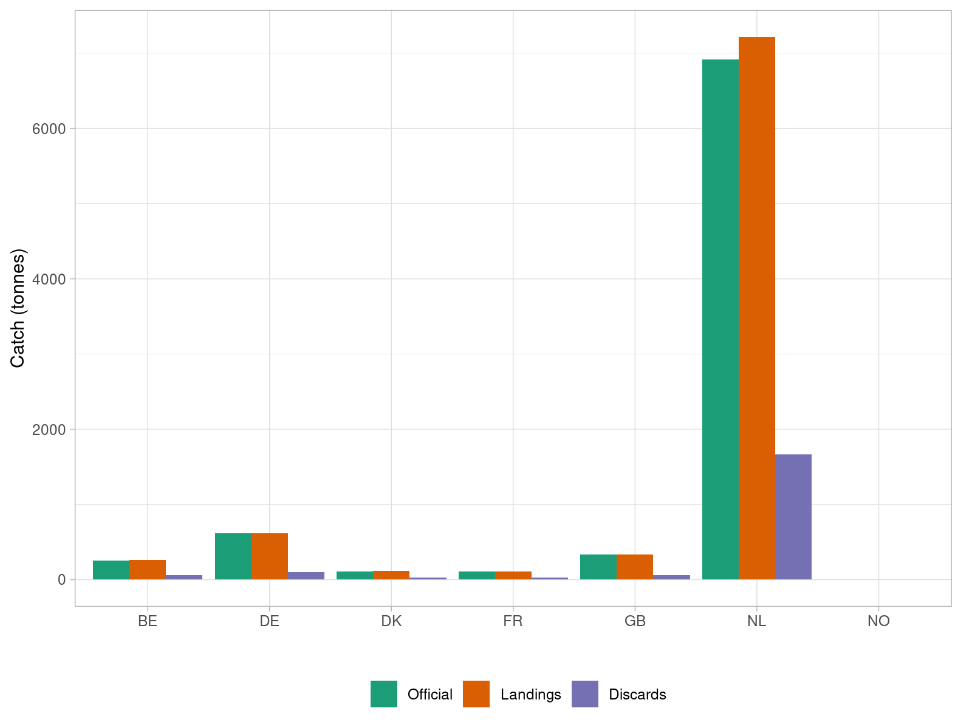

Figure 17.2.1. Sole in 27.4. Official landings, and landings and discards reported to ICES by country in 2019.

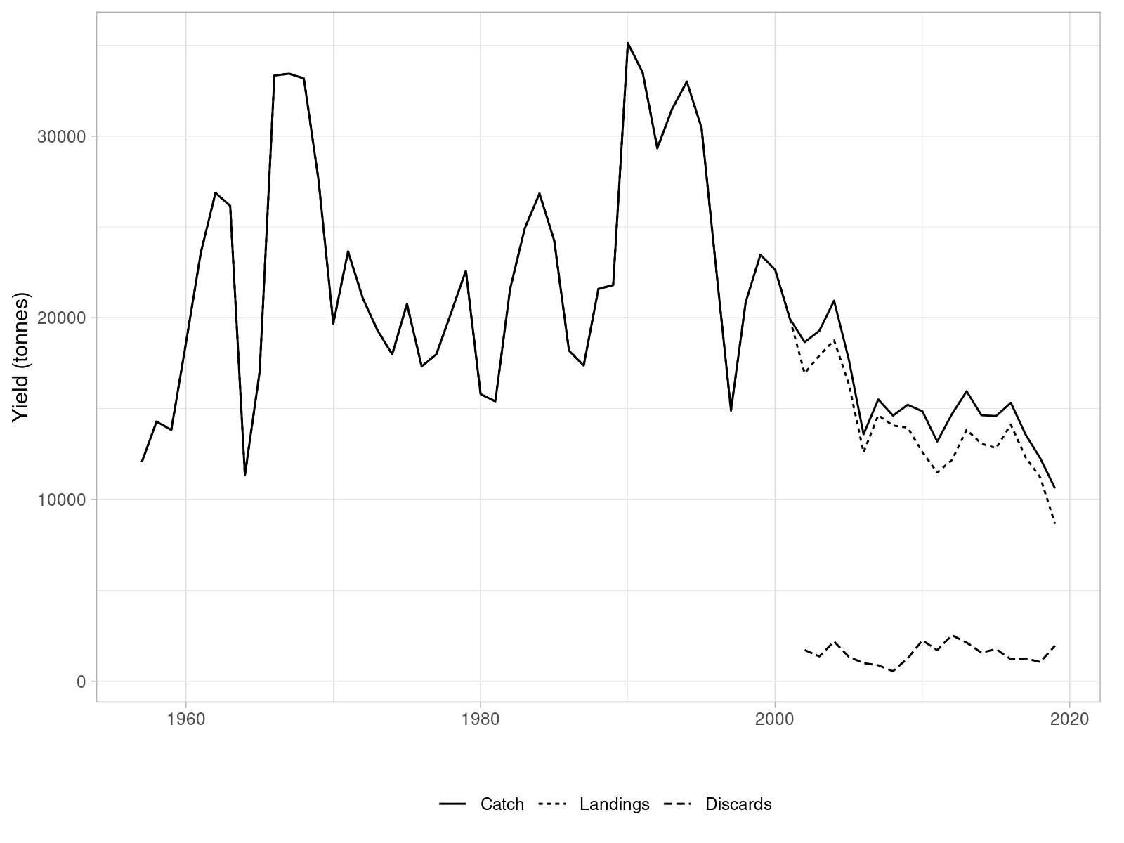

Figure 17.2.5. Sole in 27.4. Time series of catches, landings and discards (in tonnes) reported to ICES Intercatch.

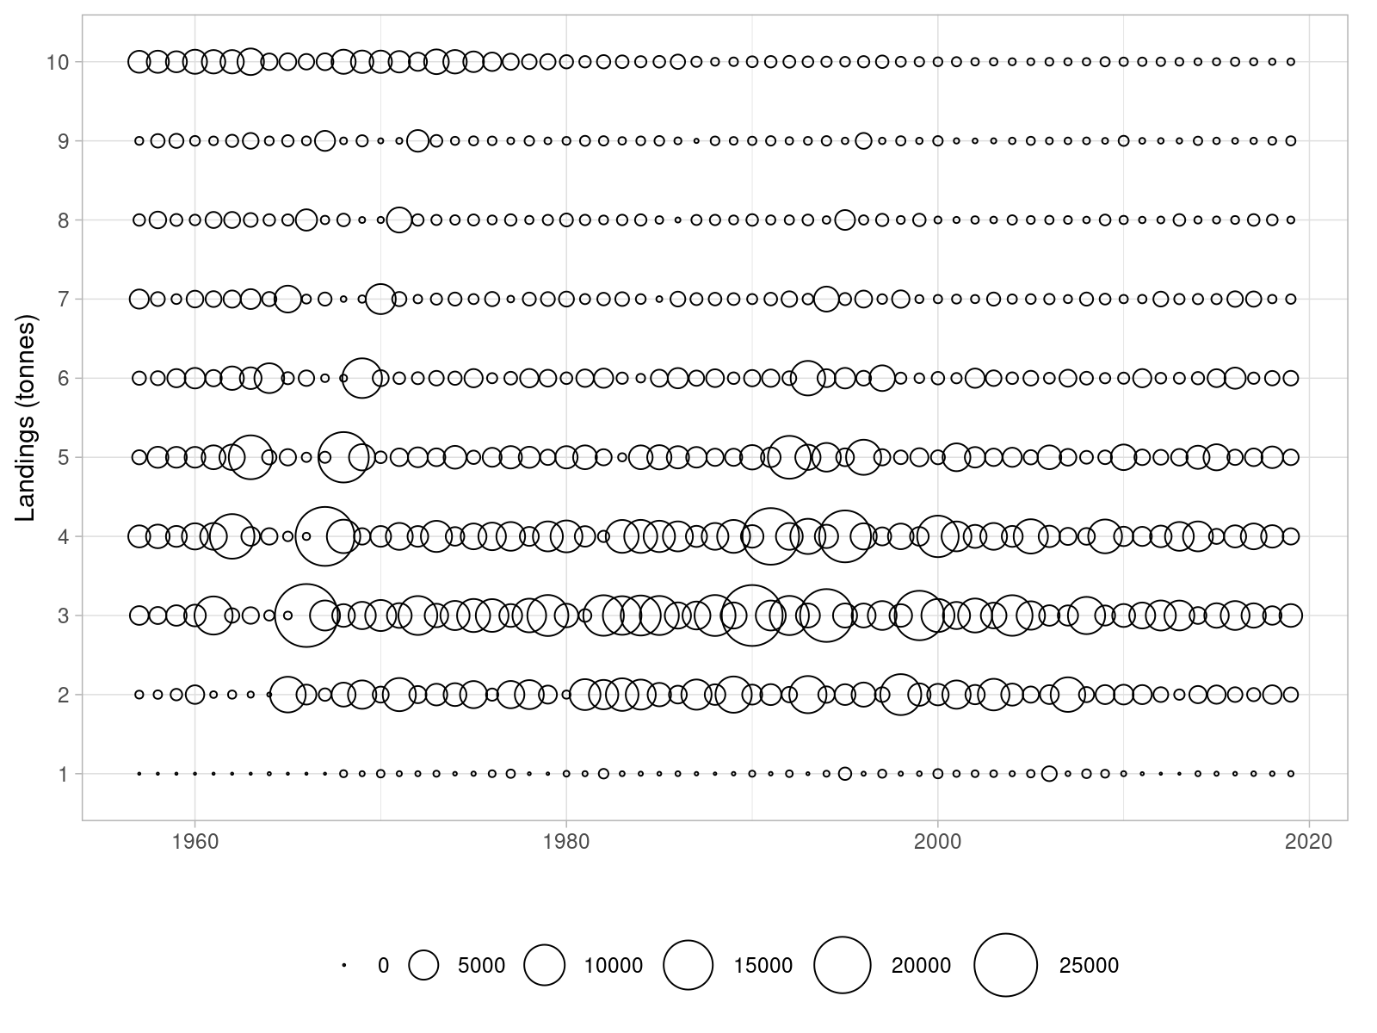

Figure 17.2.6. Sole in 27.4. Time series of landings at age (in thousands).

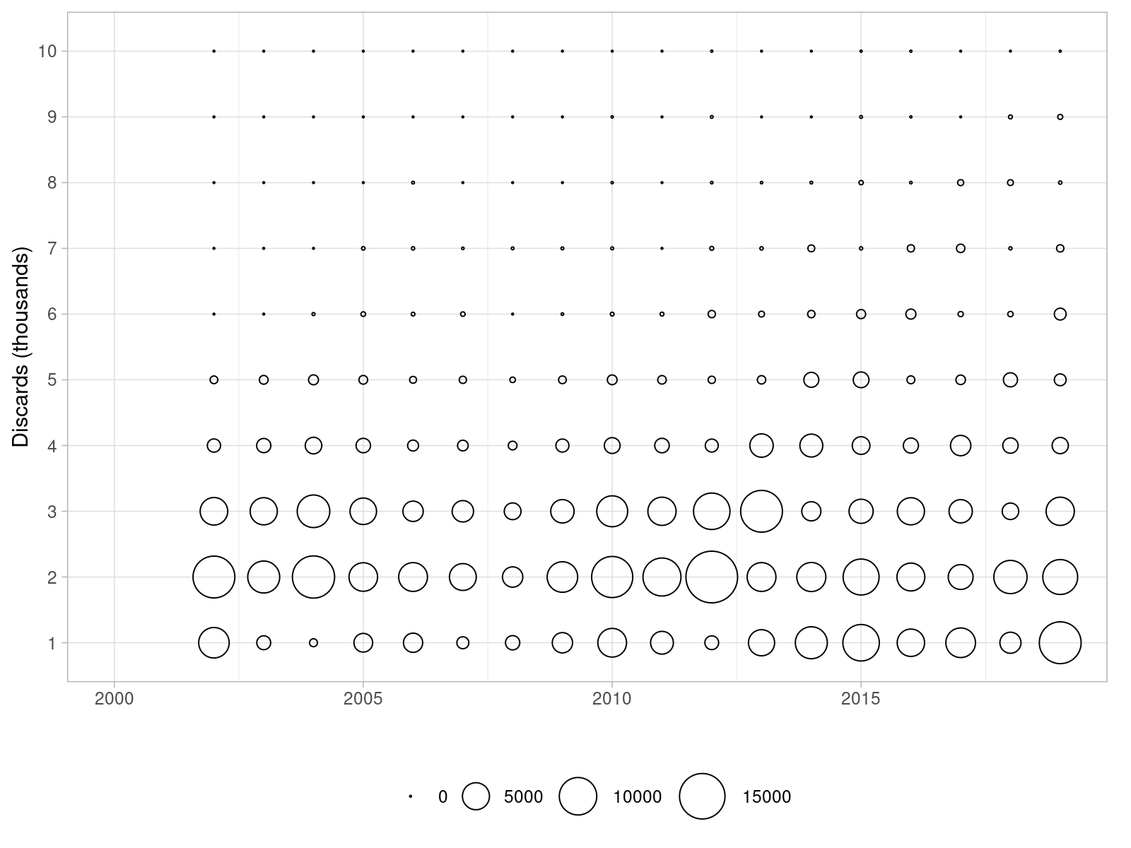

Figure 17.2.7. Sole in 27.4. Time series of discards at age (in thousands).

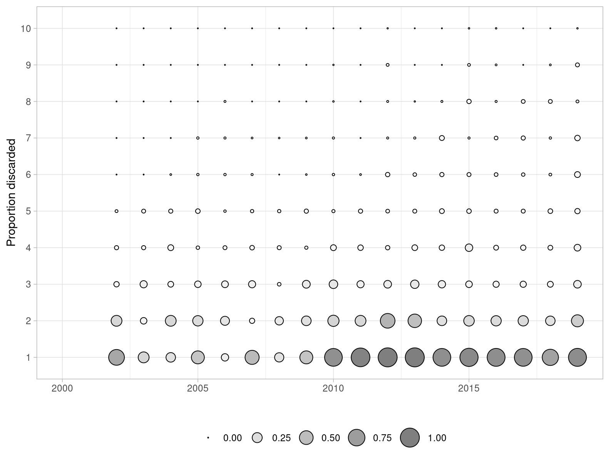

Figure 17.2.8 Sole in 27.4. Proportions of fish discarded by age over the 2002-2019 period.

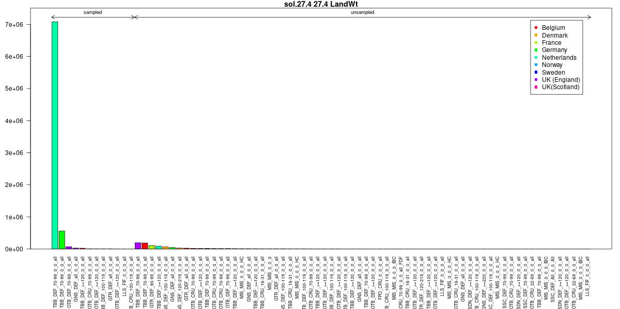

Figure 17.2.2. Sole in 27.4. InterCatch summary plots. Sampled and unsampled fleets for landings yield estimation (tonnes).

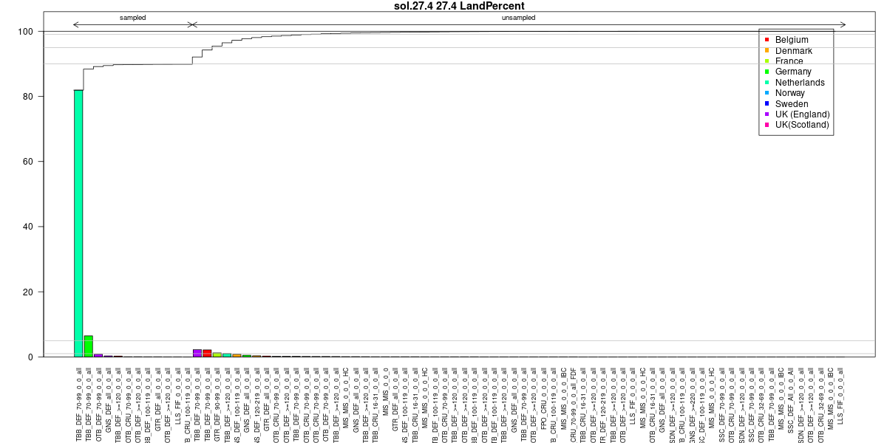

Figure 17.2.2. Sole in 27.4. InterCatch summary plots. Sampled and unsampled fleets for landings yield estimation (cumulative percentage)

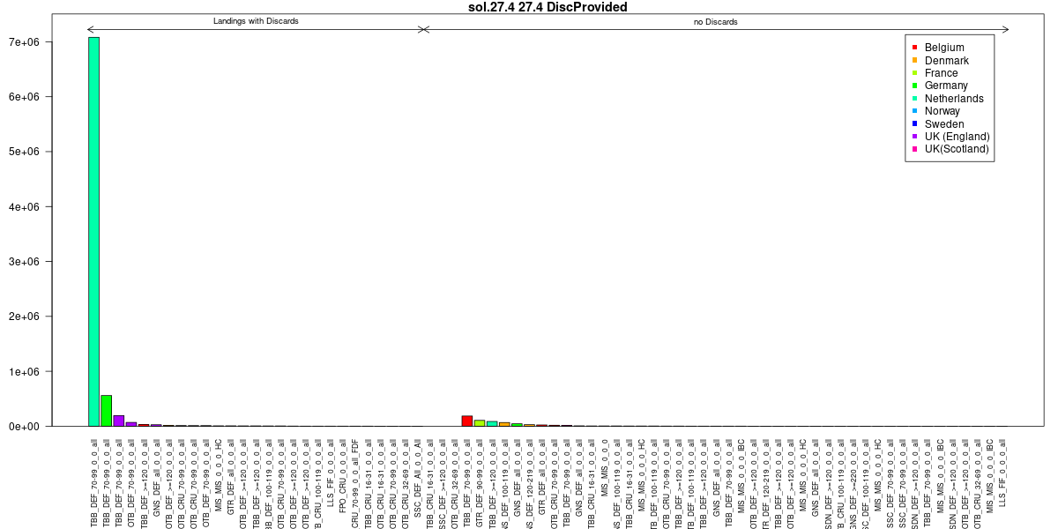

Figure 17.2.3. Sole in 27.4. InterCatch summary plots. Sampled and unsampled fleets for discards yield estimation

(tonnes).

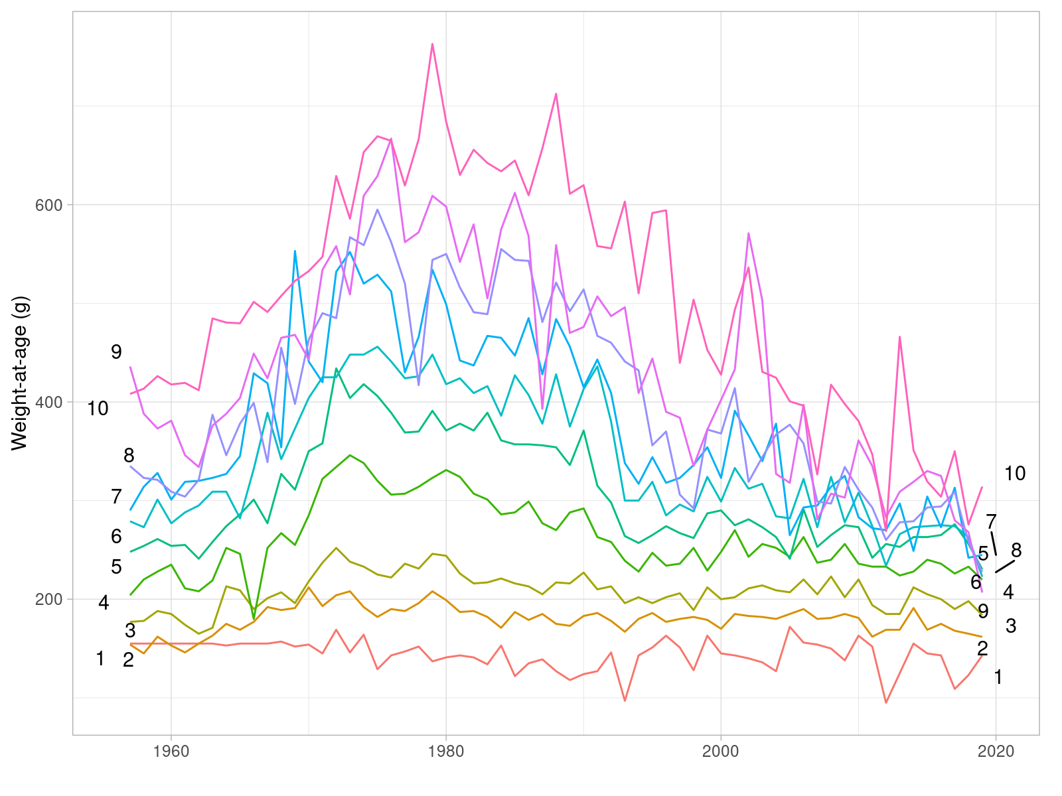

Figure 17.3.1. Sole in 27.4. Time series of mean weight-at-age in the landings (in grams).

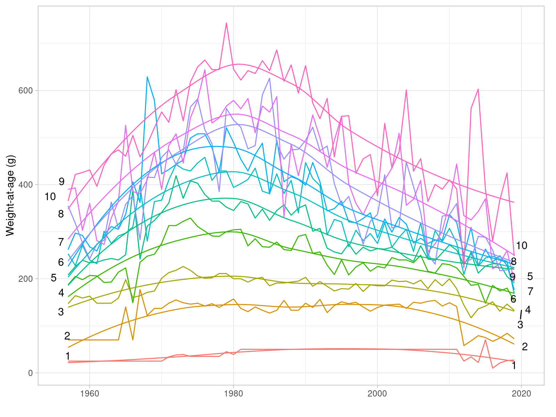

Figure 17.3.2 Sole in 27.4. Time series of mean weight-at-age in the stock (in grams).

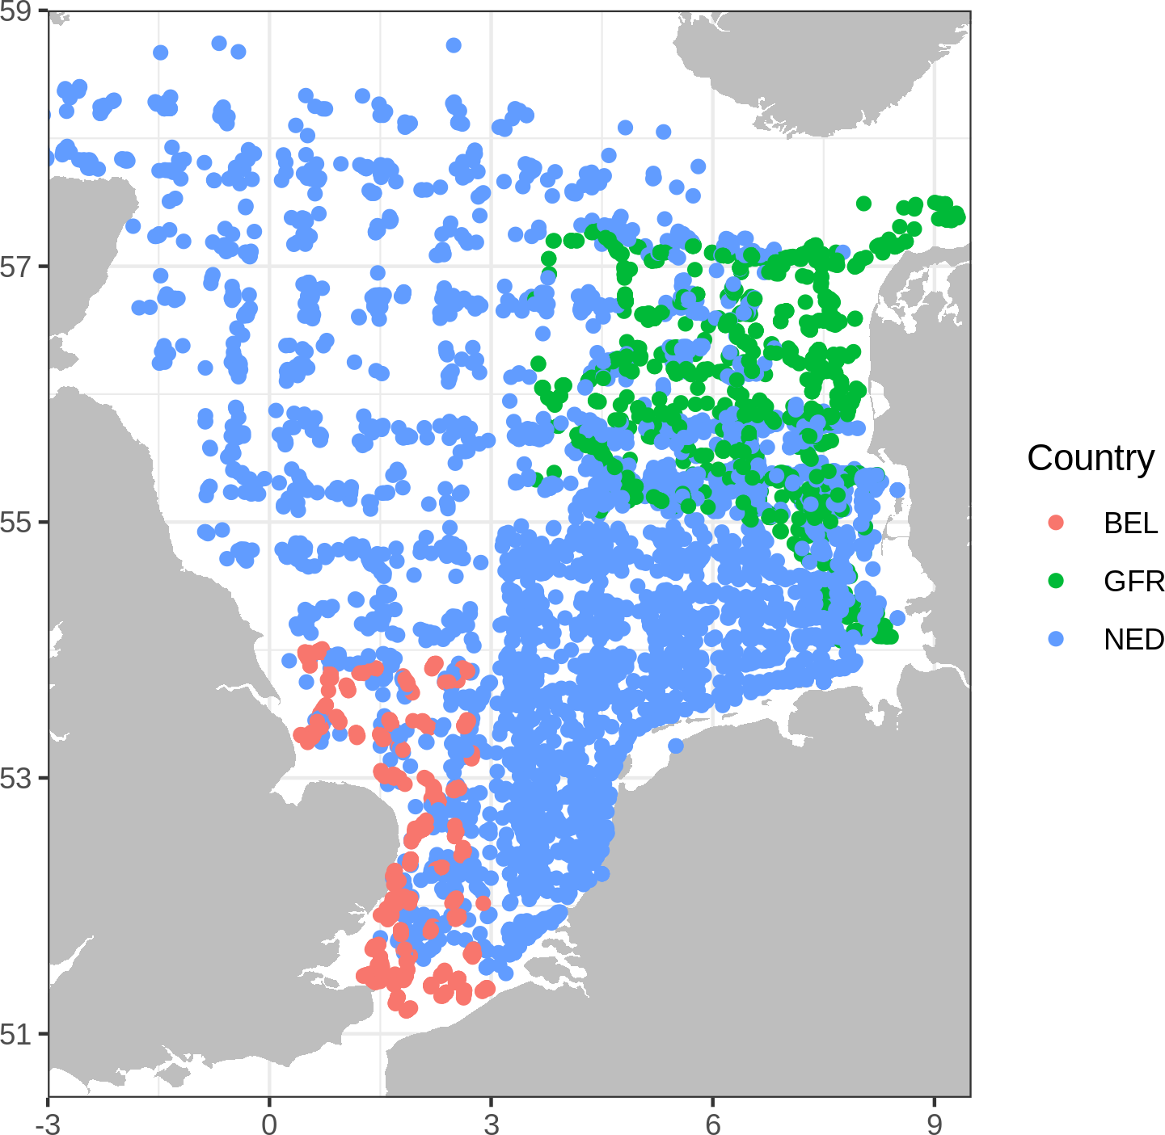

Figure 17.5.1. Sole in 27.4. Location of stations sampled during the BTS Q3 survey and included in the BTS index of abundance.

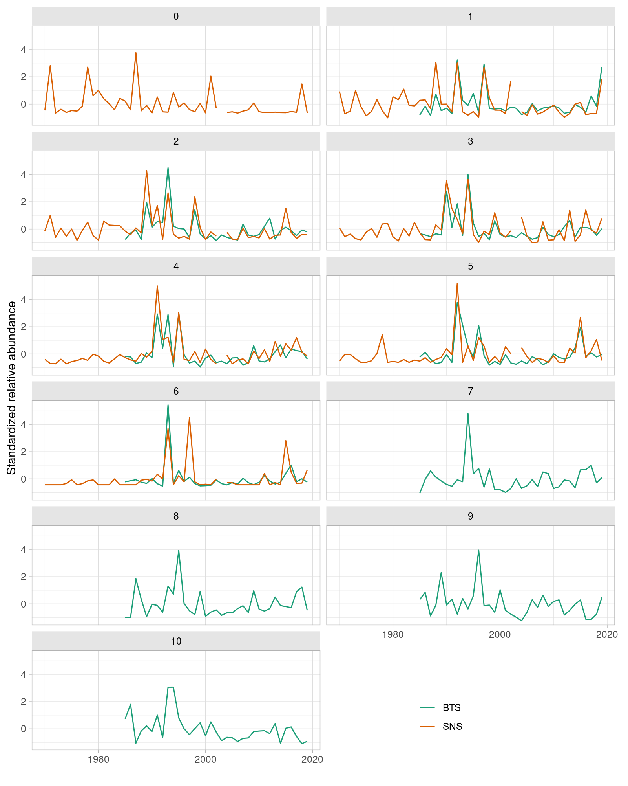

Figure 17.5.4 Sole in 27.4. Comparison of the time series of relative abundance at age from the BTS Q3 delta-lognormal GAM standardized (1985-2019) and SNS (1970-2019) indices of abundance.

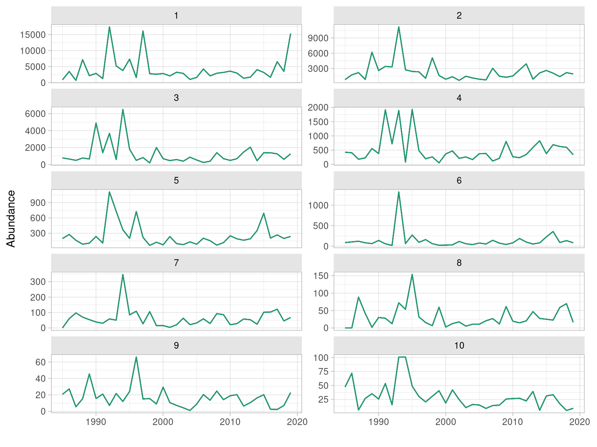

Figure 17.5.2 Sole in 27.4. Time series of relative abundance at age from the BTS Q3 delta-lognormal GAM standardized index of abundance (1985-2019).

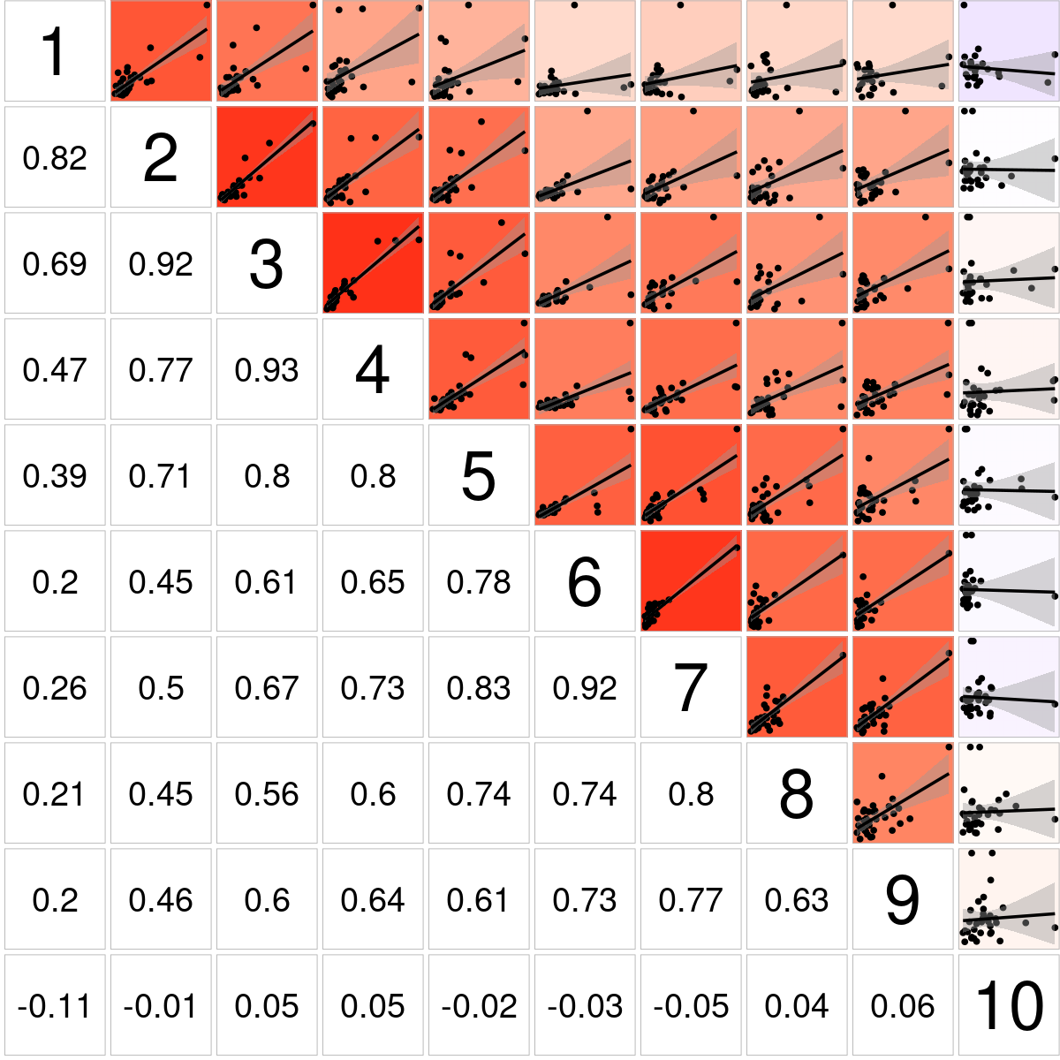

Figure 17.5.5. Sole in 27.4. Bivariate cross-correlation plots showing the internal consistency in signals by cohort for the BTS Q3 delta-lognormal GAM standardized index of abundance (1985-2019).

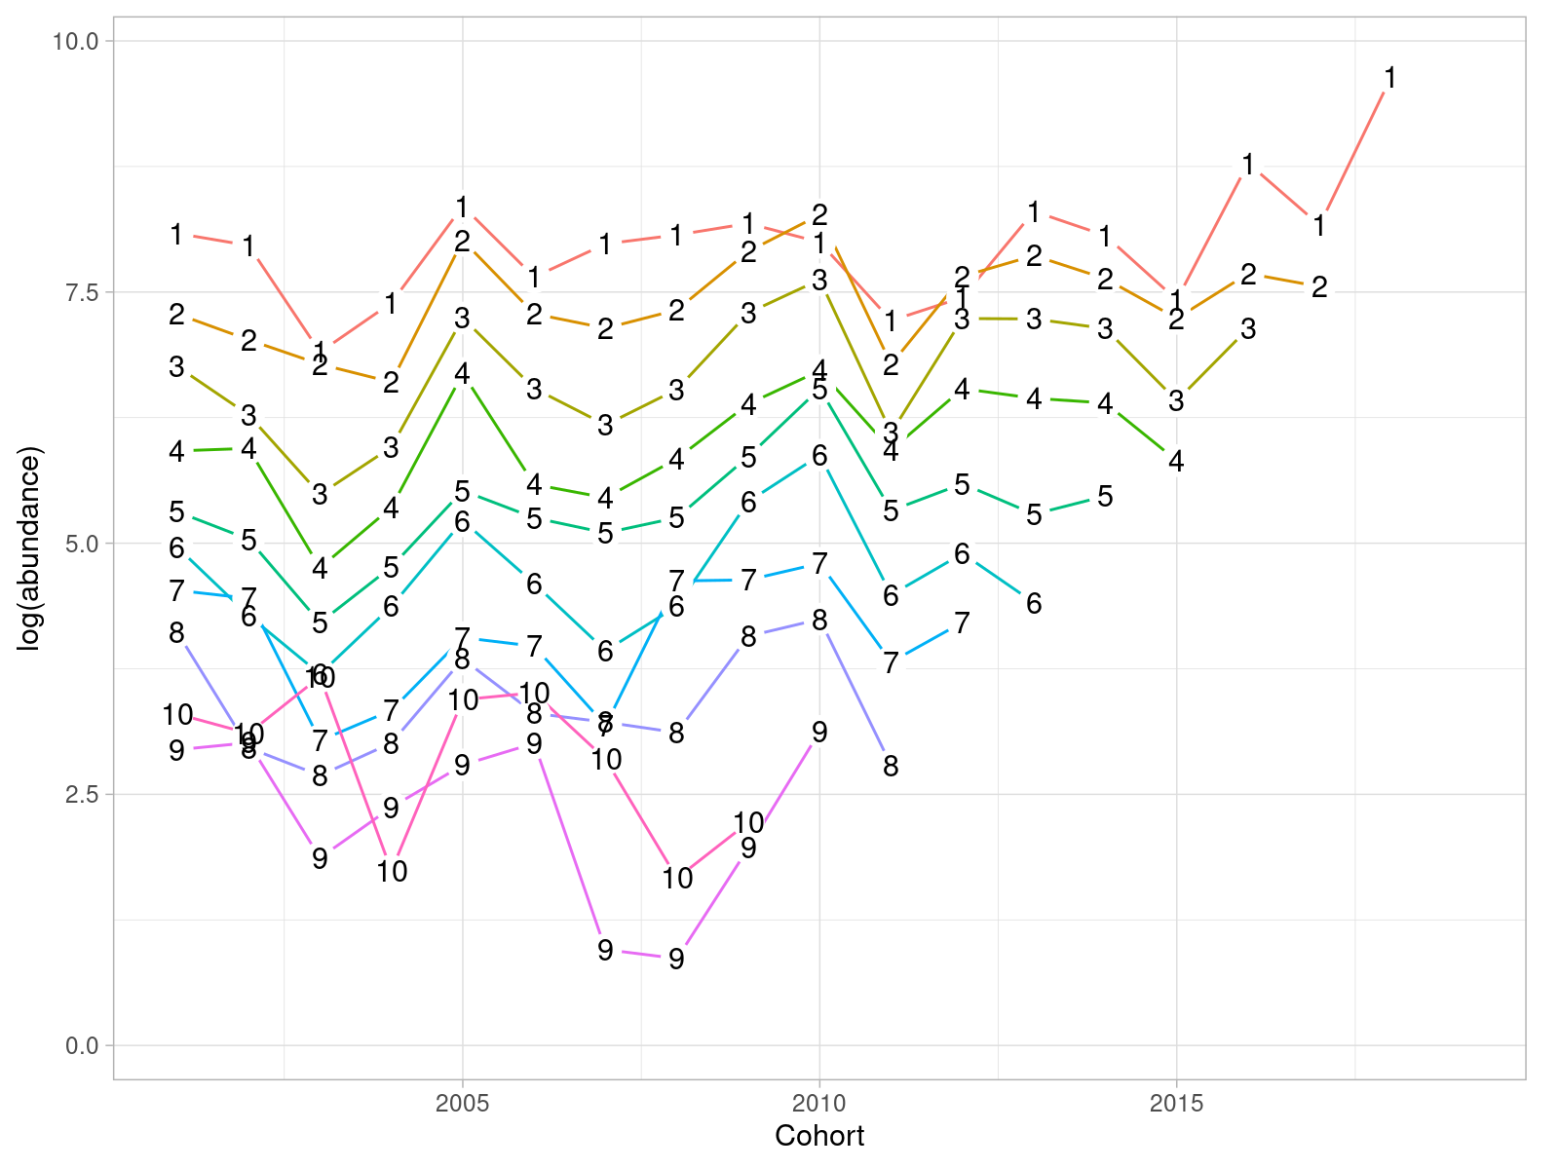

Figure 17.5.7. Sole in 27.4. Abundance in log scale by cohort (in the x axis) and age (coloured lines) for the BTS Q3 delta-lognormal GAM standardized index of abundance (2001-2019).

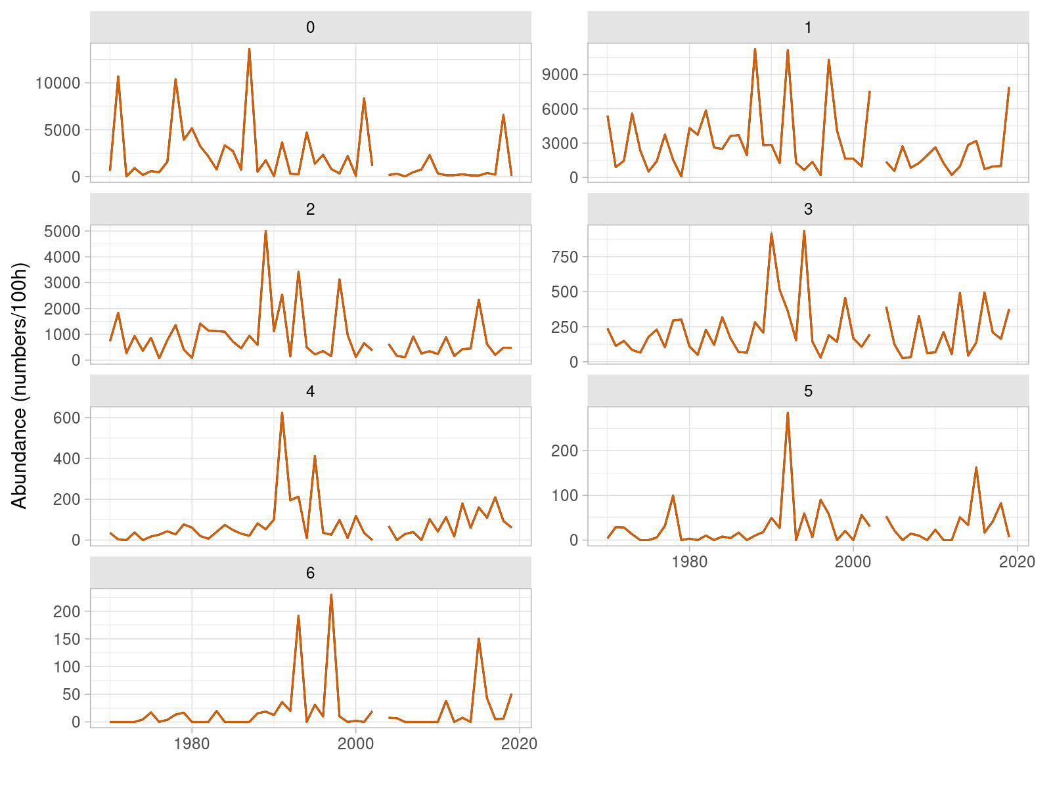

Figure 17.5.3. Sole in 27.4. Time series of relative abundance at age from the BTS Q3 delta-lognormal GAM standardized index of abundance (1985-2019).

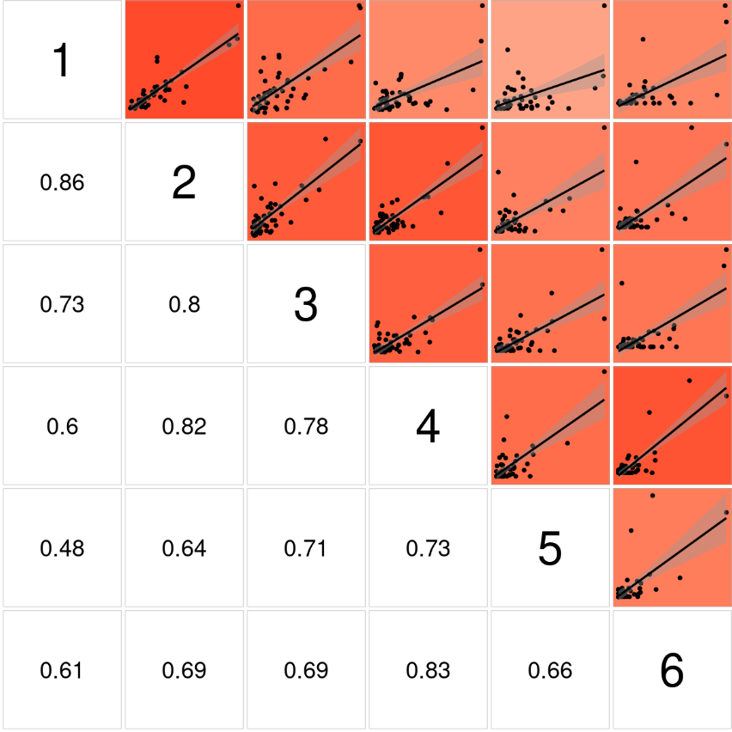

Figure 17.5.6. Sole in 27.4. Bivariate cross-correlation plots showing the internal consistency in signals by cohort for the SNS index of abundance (1970-2019).

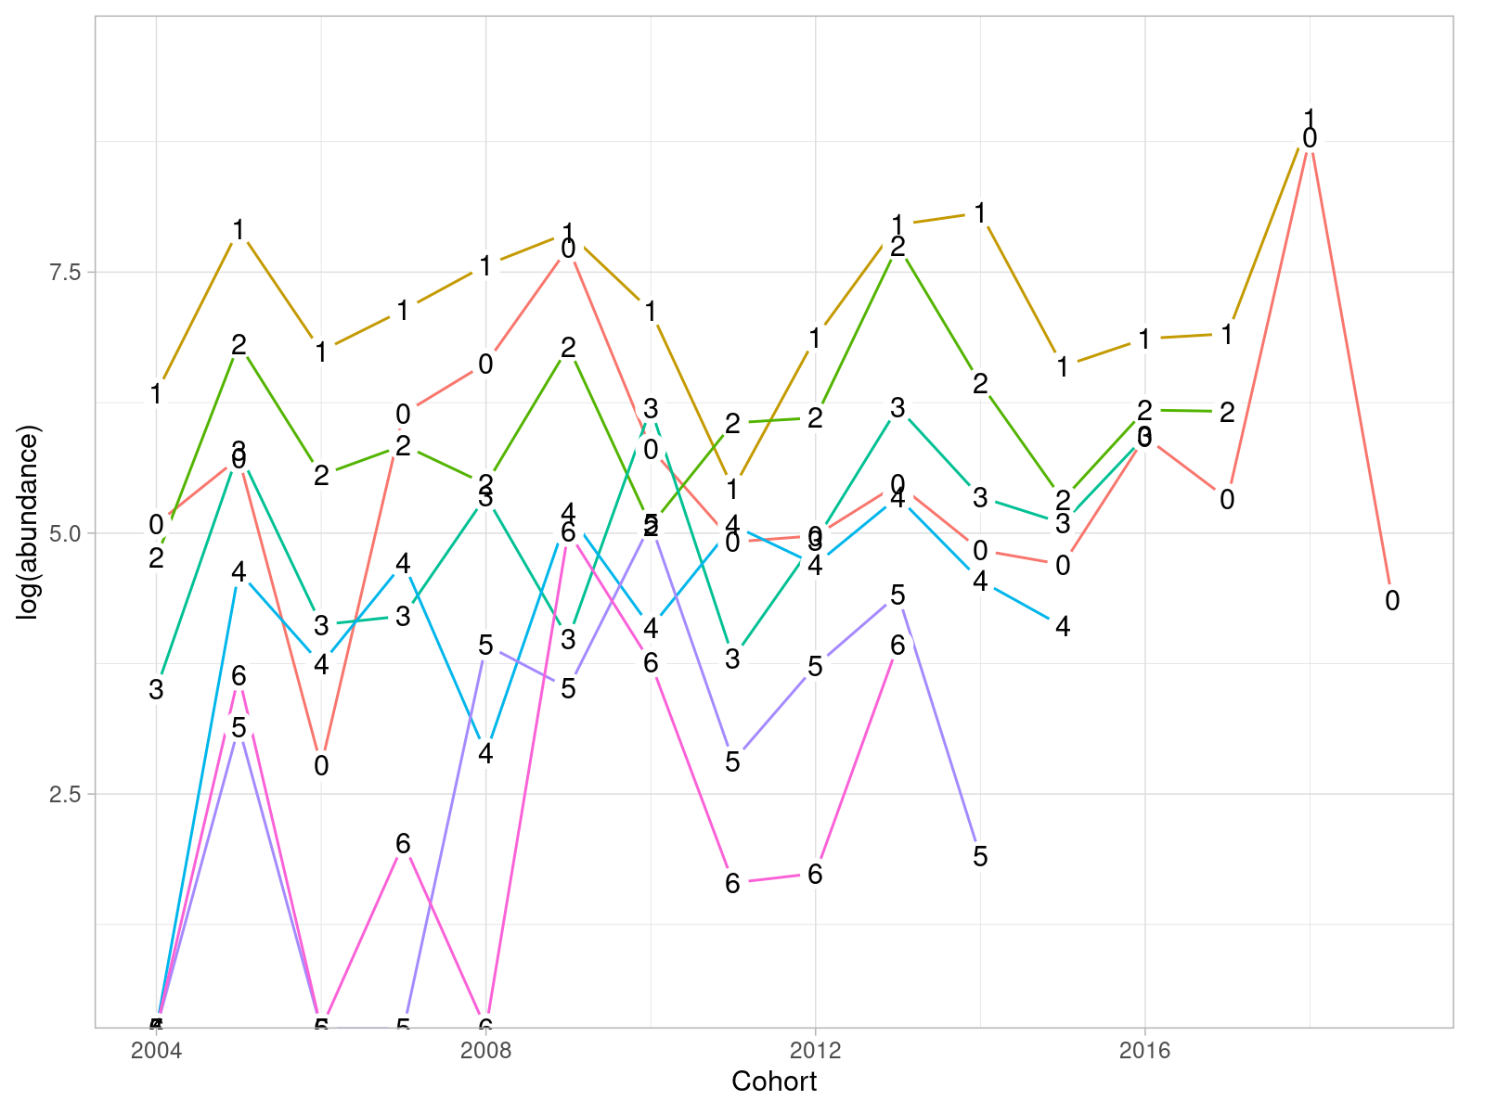

Figure 17.5.8. Sole in 27.4. Abundance in log scale by cohort (in the x axis) and age (coloured lines) for the SNS index of abundance (2004-2019).

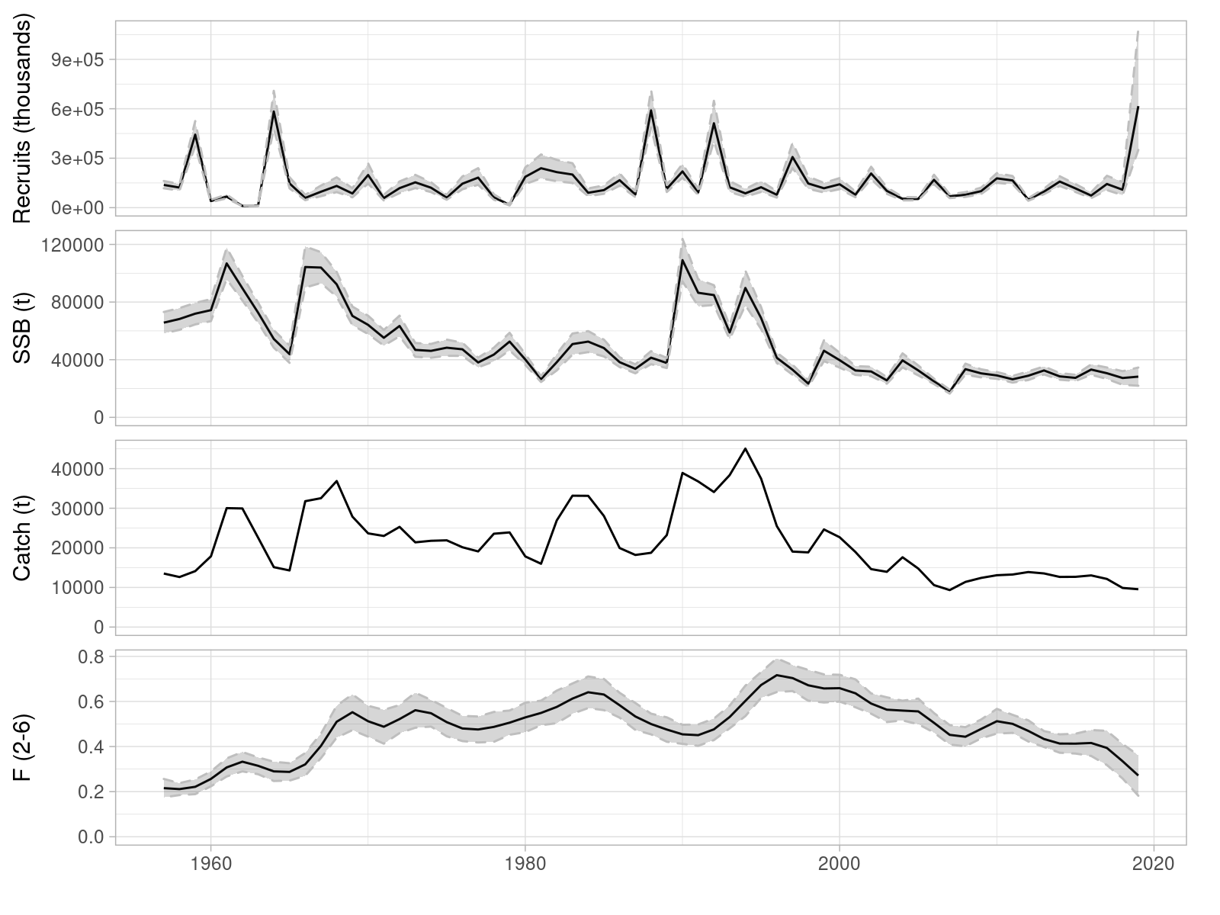

Figure 17.6.1. Sole in 27.4. Estimates time series of recruitment at age 1 (in thousands), spawning biomass (in tonnes) and fishing mortality (as average of ages 2 to 6), together with total catch (in tonnes). Grey bands show the 95% uncertainty estimate, computed as two times the standard deviation.

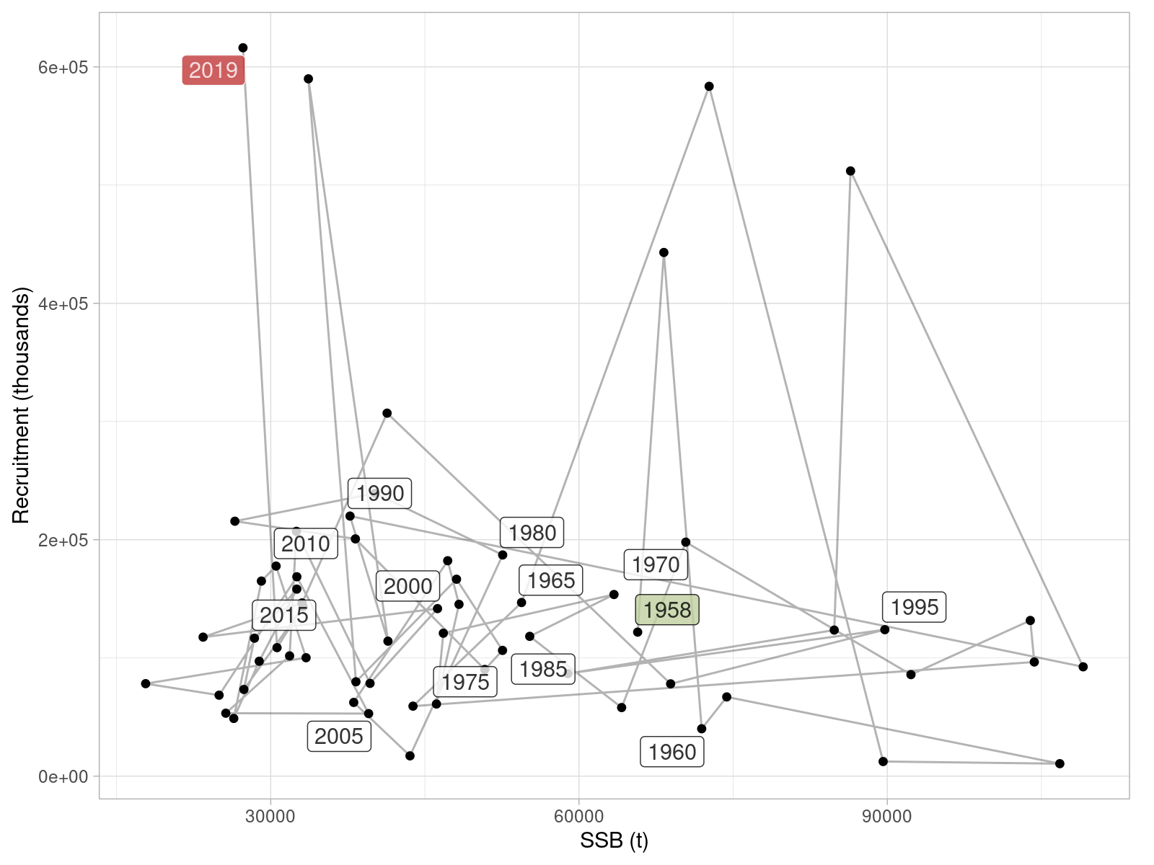

Figure 17.6.2. Sole in 27.4. Estimates of recruitment at age 1 (in thousands) and spawning biomass (in tonnes), connected in time. Labels refer to the year in which recruitment was observed.

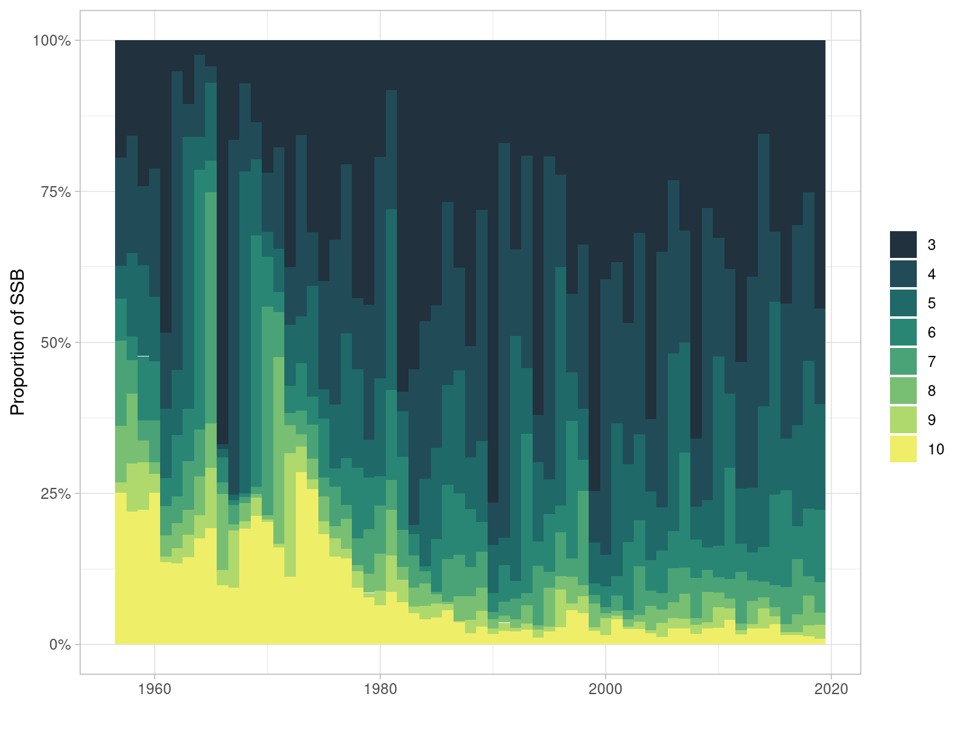

Figure 17.6.3. Sole in 27.4. Estimated proportions of spawning biomass by age and year.

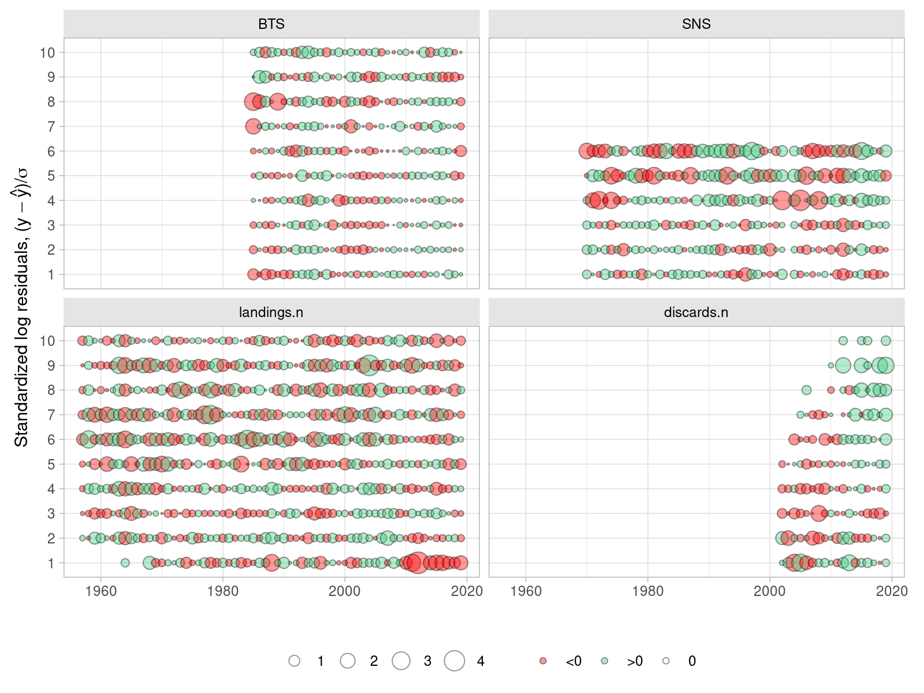

Figure 17.6.4. Residuals of model fit to the four sources of data: BTS and SNS indices of abundance, landings-at-age (landings.n) and discards-ta-age (discards.n). Residuals in log scale are standardized by the estimated standard deviation.

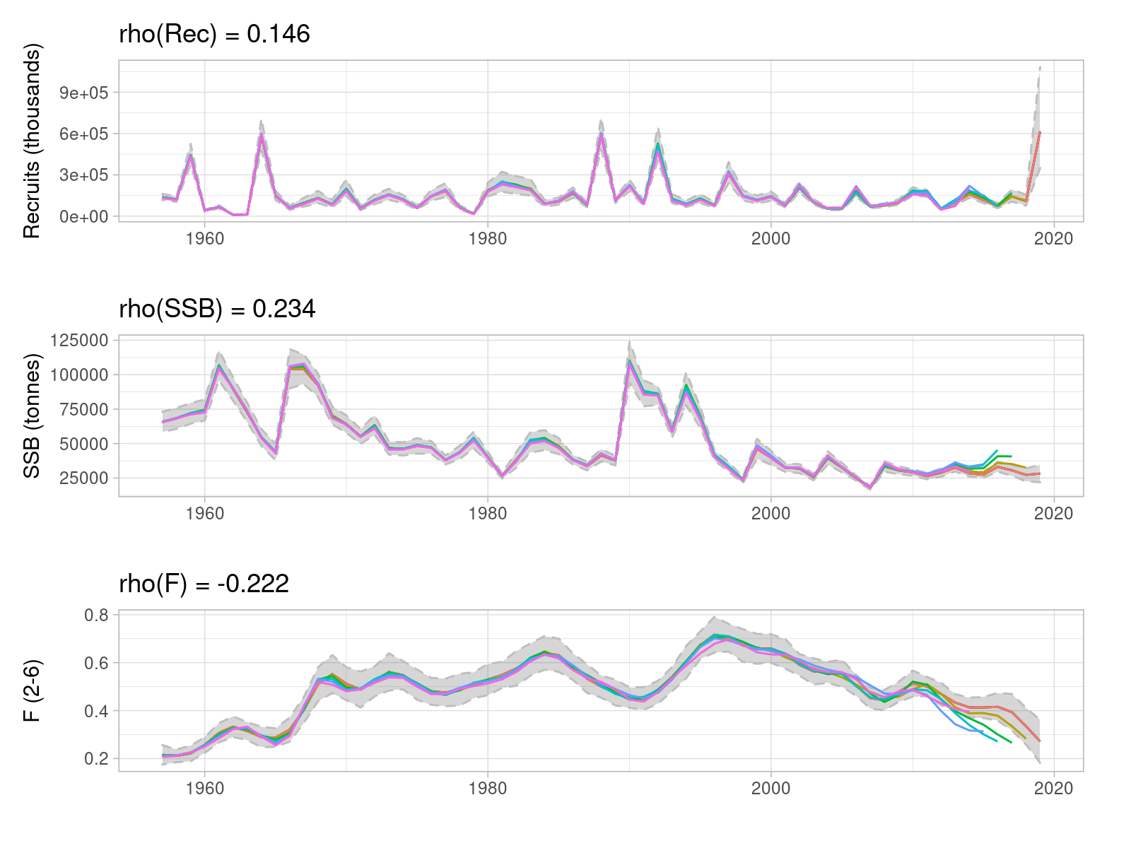

Figure 17.6.5. Sole in 27.4. Retrospective patterns in estimated age 1 recruitment, spawning biomass and mean fishing mortality, computed over five one-year steps.

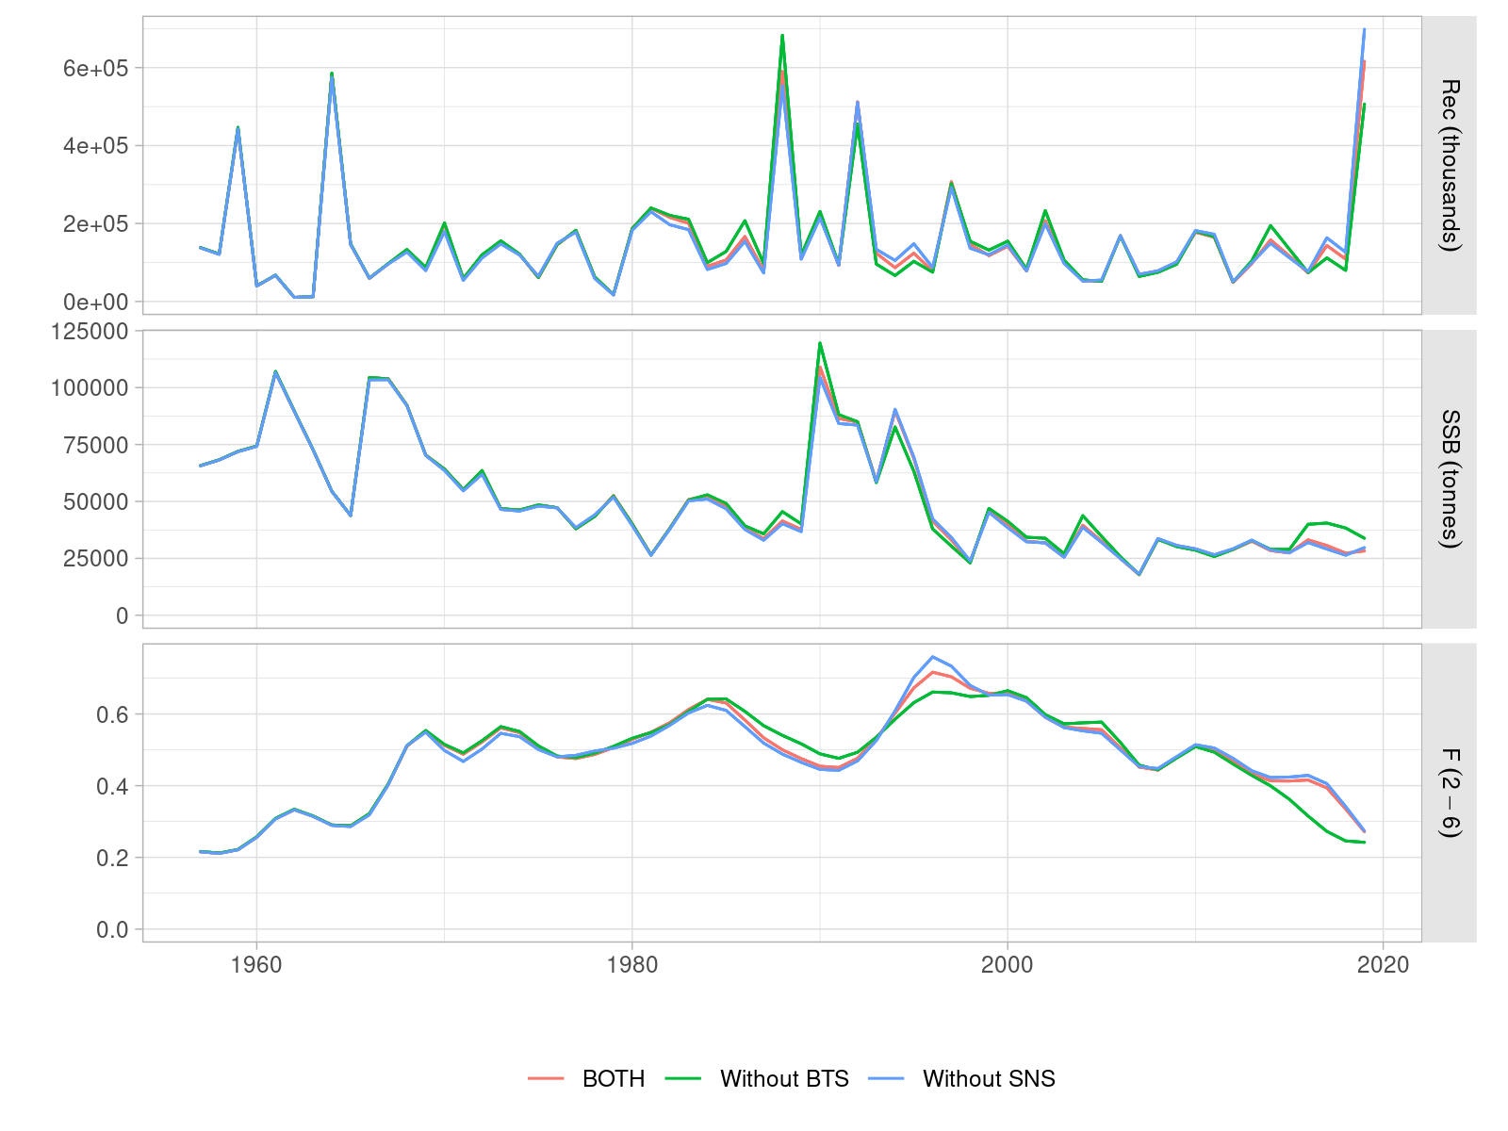

Figure 17.6.6. Leave-one-out analysis of the AAP model run.

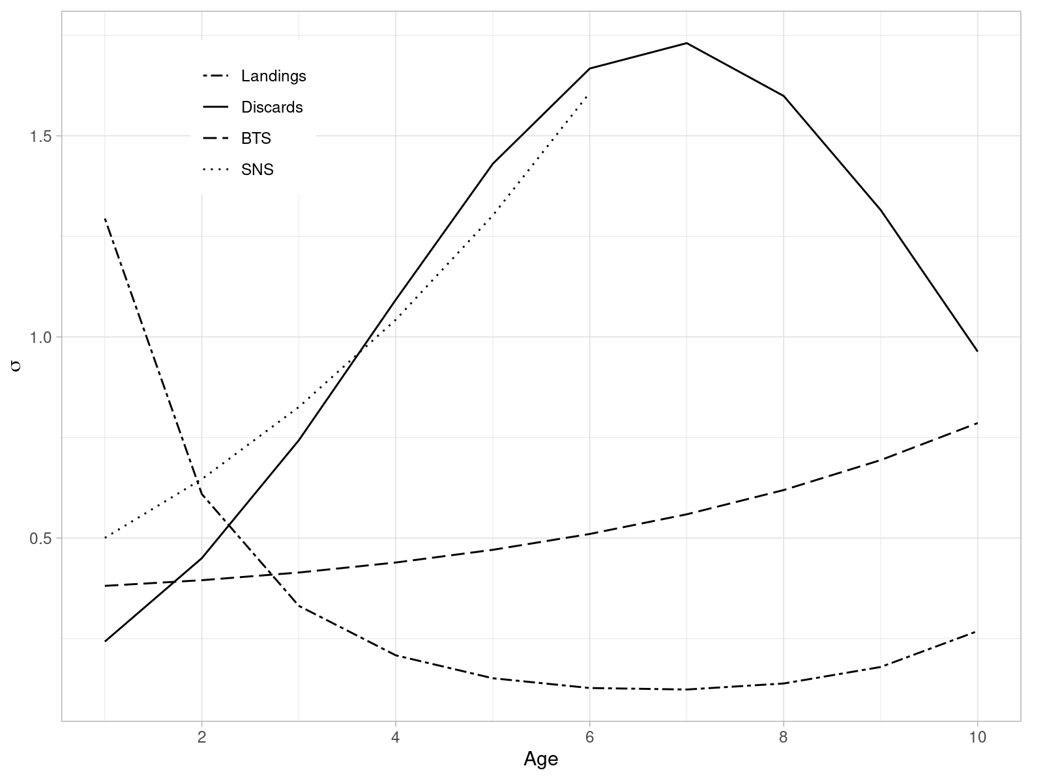

Figure 17.6.7. Sole in 27.4. Estimated standard deviations of the partial model likelihood by age and per each component.

1. Input data, source code and output of the index standardization will be available at the <https://github.com/ices-taf/2020_sol.27.4_survey/> TAF repository.
2. <https://flr-project.org>
3. <https://flr-project.org/FLasher>
4. <https://github.com/ices-taf/2020_sol.27.4_forecast/>